The views expressed in this report are those of an expert working group and do not necessarily represent those of the European Commission or the Competent Authorities. Only the European Court of Justice can give a binding opinion on EU law.

New Techniques Working Group

FINAL REPORT

1.0 Introduction

Directive 90/220/EEC (repealed and replaced by Directive 2001/18/EC) on the deliberate release of genetically modified organisms (GMOs) into the environment and Directive 90/219/EEC (amended by Directive 98/81/EC and repealed and replaced by Directive 2009/41/EC) on the contained use of genetically modified micro-organisms (GMMs) establish the basis for GMO/GMM regulation in Europe. Both pieces of legislation were adopted in parallel in 1990.

Biotechnology has found considerable application in plant breeding. For the most part, the purpose of using biotechnology in plant breeding is to introduce new traits and to achieve this in a more precise and cost-effective manner. This is the objective irrespective of whether the technique used is considered to result in genetic modification.

New breeding and genetic modification techniques have evolved at a rapid pace since the introduction of the legislation in 1990 with the result that in some instances it is unclear whether it falls under the scope of the GMO legislation. There is growing interest in using biotechnology in such a way that the resulting organism does not contain any genetic material from an organism that it could not hybridise/ breed with naturally or indeed, contain any new genetic material at all. Furthermore, in some cases the resulting changes are similar to those achievable with conventional breeding techniques.

The techniques addressed in this report were selected because it is unclear whether they would result in a GMO and whether the resulting products fall under the scope of the existing GMO/GMM legislation.

2.0 Legal context

In accordance with the deliberate release and contained use legislation, a GMO/GMM is defined as "an organism/ micro-organism ….in which the genetic material has been altered in a way that does not occur naturally by mating and/or natural recombination". Techniques, which are or are not considered to result in genetic modification, or are excluded from the scope of the GMO legislation, are listed in the respective annexes of Directives 2001/18/EC and 2009/41/EC.

An organism (any biological entity) and a micro-organism (any microbiological entity, cellular or non-cellular) must be capable of replication or of transferring genetic material.

Some techniques may include a step in the process where Directive 2009/41/EC applies. For example:
- If plant cells (in a cell culture) containing a recombinant vector are used, the cell culture may be regarded as a GMM according to the definition in Article 2 Directive 2009/41/EC. This usually takes place in a laboratory or other contained area.
- If a GMM (i.e. recombinant Agrobacterium or plant virus) is used in or on plants, its use is covered by Directive 2009/41/EC as “GMM in plants”. This usually takes place in a greenhouse or growth chamber.

Neither of the described steps necessarily affects whether the grown plant is classified as a GMO or not, if it is released into the environment; its status as a GMO will need to be considered for deliberate release under Directive 2001/18/EC.

Both Directives list techniques that:
- give rise to genetic modification (Annex I, Part A of Directive 2009/41/EC and Annex IA Part 1 of Directive 2001/18/EC);
- are not considered to result in genetic modification (Annex I, Part B of Directive 2009/41/EC and Annex IA Part 2 of Directive 2001/18/EC);
- yield organisms that are excluded from the Directive (Annex II Part A of Directive 2009/41/EC and Annex IB of Directive 2001/18/EC)

Annex I Part A of Directive 2009/41/EC and Annex IA Part 1 of Directive 2001/18/EC (techniques giving rise to genetic modification) use the wording 'inter alia' and therefore provide indicative lists of techniques leading to genetic modification. The remaining Annexes provide exhaustive lists. Therefore, the techniques leading to genetic modification are not limited to those listed under Annex I Part A of Directive 2009/41/EC and Annex IA Part 1 of the Directive 2001/18/EC.

The Annexes of both Directives are broadly similar with one exception. Directive 2009/41/EC excludes self-cloning from the scope of the legislation. Self-cloning is where a nucleic acid is removed from the cell of an organism and all or part of the nucleic acid is reinserted into cells of the same or a phylogenetically closely related species (see Appendix 4).

3.0 Establishment of the New Techniques Working Group (NTWG)

At the request of the Competent Authorities (CA) under Directive 2001/18/EC, a working group (WG) was established (October 2007) to analyse a non-exhaustive list of techniques for which it is unclear whether they would result in a GMO. CAs were invited to nominate two experts per Member State. A first list of techniques was compiled by the CAs (section 3.2). In addition, the CAs contributed to and approved a mandate for the WG (Appendix 1).

The findings of the WG are applicable to the relevant techniques in general but are focussed primarily on the implications for plant breeding. The report also refers to micro-organisms produced using new techniques in biotechnology. However, apart from the section on synthetic genomics, the focus is on plant breeding. This reflects the techniques that have been identified for consideration.

The mandate does not take account of safety issues. Nevertheless, it was agreed at the initial meeting that comments on safety aspects would be taken into consideration where such comments were raised.

The WG met nine times (15 December 2008, 9 February 2009, 24 April 2009, 18/19 June 2009, 21/22 September 2009, 21/22 January 2010, 26/27 January 2011, 23/24 February 2011 and 27/28 April 2011). It is the function of the WG to make its findings available to CAs in the form of technical advice. Therefore, in accordance with the mandate the outcome of the WG will be presented to a meeting of the Competent Authorities under each Directive or to a joint meeting of the Competent Authorities under the two Directives. The MS experts who participated in the deliberations of the WG are provided in Appendix 2.

It is envisaged that the results of the WG will be viewed in parallel with the results of the evaluation exercise of the GMO legislation on food/feed and cultivation, which was finalized and published on 28 October 2011. It will also be viewed in conjunction with a study led by the European Commission's Joint Research Centre (JRC) Institute for Prospective Technological Studies (IPTS) in cooperation with the JRC Institute for Health and Consumer Protection (IHCP). This study, which was published in May 2011, investigates the degree of development and adoption of new plant breeding techniques by the breeding sector and discusses drivers and constraints for further commercial adoption. It also highlights studies on food, feed and environmental safety and evaluates difficulties for detecting and identifying crops produced by the new plant breeding techniques.

The Commission has asked EFSA to address the following considerations in separate opinions per technique or per groups of techniques, as appropriate:
- Determine whether there is a need for new guidance or whether the existing guidance on risk assessment should to be updated or further elaborated, in anticipation of the placing of products on the market through the application of the listed techniques.
- What are the risks in terms of impact on humans, animals and the environment that the eight techniques listed could pose, irrespective of whether or not they fall under the GMO legislation? This latter request should consider the most recent scientific literature and knowledge of plant breeding experts and compare plants obtained by these new techniques with plants obtained by conventional plant breeding techniques and secondly with plants obtained with currently used genetic modification techniques.

3.1 Approach taken by the experts

The WG considered the most recently available scientific data to define and analyse the techniques under consideration. As established in the mandate, each ‘new technique’ was evaluated in the context of the GMO/GMM definition and the annexes of each Directive. The WG considered each technique to determine whether the definitions in the GMO/GMM legislation applied and whether the resulting organism has been altered at all. The WG also took into account whether and if so, to what extent, the techniques were captured by the examples listed in Annex 1A of Directive 2001/18/EC and Annex 1 Parts A and B of Directive 2009/41/EC and the characteristics of the resulting organism with respect to terms used in these two annexes. For instance, by considering whether new combinations of genetic material have been generated, whether new nucleic acid molecules have been inserted into the organism or whether they are present transiently and not capable of continued propagation i.e. heritable/inherited. In addition, experts considered whether the alteration in the resulting organism could be produced by traditional techniques or in nature and the extent to which the resulting organisms could be distinguished from organisms resulting from the use of traditional techniques.

The experts recognised that the annexes in the Directives were drafted before these techniques were developed and as such are not necessarily fit for purpose. Since some of the techniques analysed are not properly captured by the examples of GM techniques nor by the list of techniques that are not considered to result in genetic modification, the experts have also provided additional remarks that could be used by regulators in the follow-up to the report. More specifically, given that the existing Directives exempt organisms obtained through an exhaustive list of techniques of genetic modification, the WG indicated whether and why some techniques could qualify for inclusion into such list as a result of potential future revisions of Annex IB of Directive 2001/18/EC and Annex II Part A of Directive 2009/41/EC or for possible guidelines relating to the Annex I of Directive 2001/18/EC and Annex II of Directive 2009/41/EC (among other possible follow up actions to this report).

Experts noted that some of the techniques under consideration are processes that involve multiple steps. Whether the whole process or the different technical steps within it are defined as ‘techniques of genetic modification’ may be significant in terms of determining the status of the organisms produced at these different stages. Therefore, where multiple steps are associated with a ‘new technique’, experts considered it valuable and transparent to assess these individual steps separately to determine whether or not they yield GMOs as defined in the Directive(s).

3.2 ‘New techniques’ considered by the WG

The following techniques were proposed by the CAs for consideration by the "new techniques working group":
- Oligonucleotide Directed Mutagenesis (ODM)
- Zinc Finger Nuclease Technology (ZFN) (comprising ZFN-1, ZFN-2 and ZFN-3 as defined in this report )
- Cisgenesis (comprising Cisgenesis and Intragenesis)
- Grafting
- Agro-infiltration
- RNA-dependent DNA methylation (RdDM)
- Reverse Breeding
- Synthetic Genomics

4.0 Terms and issues discussed

There are certain terms in use in the legislation that influence considerations on whether a specific technique and or a resulting organism falls within the scope of the legislation, depending on the interpretation of the term. These terms were discussed separately in order to gain clarity and common agreement within the group and in order to make the conclusions of the group on the specific techniques more logical and robust.

In addition, issues such as 'transient presence/effect' and 'GMO offspring' were deemed equally relevant to the discussions and were similarly discussed.

When analysing organisms produced by a particular technique in the light of the criteria set out in Annex IB of Directive 2001/18/EC and Annex II Part A of Directive 2009/41/EC, a key consideration was whether these techniques involve the use of recombinant nucleic acid molecules or GMOs/GMMs other than those produced by mutagenesis and cell fusion (including protoplast fusion) and in the case of GMMs, self-cloning.

4.1 "..altered in a way…."

The term "altered in a way" is used in Article 2(2) of Directive 2001/18/EC and Article 2(b) of Directive 2009/41/EC which define GMO and GMM respectively as an "organism” or “micro-organism in which the genetic material has been altered in a way that does not occur naturally by mating and/or natural recombination". The techniques ("process") leading to the generation of GMOs are listed under Annex IA Part 1 of Directive 2001/18/EC and Annex I, Part A of Directive 2009/41/EC, and under Annex IB of Directive 2001/18/EC and Annex II Part A of Directive 2009/41/EC (Section 2.0 of this document provides an overview of the annexes and their respective techniques).

The experts recognized that the term "altered in a way" could be interpreted in one of two ways:
- The emphasis is on the technique; the resulting organism is a GMO, even if the same modification or an identical organism could be obtained by the techniques listed in Annex I A Part 2 or Annex I B of Directive 2001/18/EC and Annex I Part B or Annex II Part A of Directive 2009/41/EC.
- The emphasis is on the resulting organism; if the resulting organism is indistinguishable from an organism obtained from natural processes, conventional breeding or by application of the techniques listed in Annex IA Part 2 or Annex IB of Directive. 2001/18/EC and Annex I Part B or Annex II Part A of Directive. 2009/41/EC, then it cannot be considered as a GMO and would therefore be considered out of the scope of the Directives. (Article 2)

Experts also discussed the degree of change that should be considered an alteration according to the Directives, given the plasticity of genomes and the genetic variation that occurs naturally and through traditional breeding techniques. A minority of experts considered a single base pair change was sufficient to be captured by the legislation.

4.2 Nucleic acids and recombinant nucleic acid

The term "nucleic acid" is used in Annex IA Part 1(1) of Directive 2001/18/EC and Annex I Part A(1) of Directive 2009/41/EC.

Nucleic acid molecules e.g. DNA and RNA can be produced naturally or by synthetic means. In some of the techniques proposed for consideration, synthetic analogues of nucleic acids or nucleic acids containing synthetic nucleotide analogues are used, such as locked nucleic acids (LNA) and peptide nucleic acids (PNA).

LNA and PNA have different chemical properties from DNA and RNA and can behave differently in vivo compared to nucleic acid molecules e.g. in replication, transcription and translation. It was noted that LNA or PNA are used in the same way as nucleic acids, i.e. as tools to alter the genetic material in cells for example for the purpose of site-directed mutagenesis.

The term "recombinant nucleic acid molecules" is used in Annex IB of Directive 2001/18/EC and Annex II Part A of Directive 2009/41/EC. In line with the aforementioned Directives, a recombinant nucleic acid molecule is created outside the cells through the formation of a new combination of genetic material/nucleic acid molecules. There was a discussion on how many nucleotides could constitute a new combination of genetic material/nucleic acid molecules in this context. A majority of experts concluded that in order to form a new combination, a nucleotide sequence of at least 20 bp is required. A minority of experts were of the opinion that under the current definition, the replacement of only one nucleotide in a nucleic acid molecule could be interpreted as producing a recombinant nucleic acid.

The definition of a recombinant nucleic acid molecule is important because Annex IB of Directive 2001/18/EC and Annex II Part A of Directive 2009/41/EC both stipulate that techniques/methods of genetic modification yielding organisms to be excluded from the Directive, may only be excluded on the condition that they do not involve the use of recombinant nucleic acid molecules.

4.3 Heritable material

The term heritable material is used in Annex IA, Part 1(2) and Part 1(3) of Directive 2001/18/EC and Annex I, Part A(2) and Part A(3) of Directive 2009/41/EC. In both instances the term is used in the context of genetic material, which, when introduced directly (i.e. without the involvement of a vector system) into an organism (micro-organism) by procedures including micro-injection, micro-encapsulation or cell fusion, will result in a "technique of genetic modification" in the sense of the Directives. Although heritable material is not clearly defined in the Directive, there are two possible interpretations:

i. "heritable material” must be inherited in the case in question. The argument being that the first indent in the list of Annex IA Part 1 involves the use of vectors and refers to the transfer of genetic material into a host organism and continued propagation. In order for this to be consistent with the second indent in the list of Annex IA Part 1 heritable material should be interpreted as being propagated through the host organism and not just being transiently present (see section 4.4); and,

ii. "heritable material” has simply to be capable of being inherited.

GMOs that have been authorised to date, and into which ‘heritable material prepared outside of the organism’ has been introduced directly, have in all cases been capable of passing this material onto their offspring. Whereas, nucleic acid introduced into cells using some of these new techniques will not be inherited e.g. in the case of ODM, ZFN-1 ZFN-2 and RNA-dependent DNA methylation. However, the changes they impart will be inherited (although this is limited in the case of RNA-dependent DNA methylation).

The consequences for taking these different approaches when considering whether ZFN and ODM are captured by Annex 1A Part 1 are addressed in the specific sections (5.1 and 5.2, respectively).

4.4 GMO offspring

Offspring is a product of reproduction of organisms. Reproduction can be sexually or asexually
- In the case of sexual propagation in plants, the offspring are the product of two parents.
- In the case of vegetative propagation in plants, the offspring is the product of a single parent.
- In the case of animals it is essentially the same, but asexual propagation is rare, e.g. parthenogenesis, or does not happen naturally, e.g. “cloning”.
- In the case of prokaryotic micro-organisms and eukaryotic cell cultures, reproduction occurs by cell division (asexual).
- In the case of eukaryotic micro-organisms, such as fungi, reproduction can occur sexually as well as asexually.
- In the case of viruses and other non-cellular entities such as viroids, reproduction occurs by biosynthetic copying, e.g. of the viral nucleic acids in a host cell, such as plant, animal or microbial cells.

Some of the techniques discussed in this report involve intermediate organisms or cells that contain new DNA. Further on in the process, however, some of these intermediate organisms or cells give rise to offspring that no longer contain the new DNA. In the NTWG different views were expressed on whether and when the offspring of a GMO can be classified as a non-GMO. This aspect is not considered in the Directives.

For the techniques described in this report all experts agree that unintended changes in the DNA sequence due to the (former) presence/insertion of the new DNA may have taken place, and would probably appear at very low frequency. If such unintended changes appeared, they would be comparable to natural or induced changes not involving techniques that lead to GMO. All experts agreed that once it is established that the 'foreign' genetic material is no longer present in the resulting organism it is no longer considered a GMO, however, some expert raised concerns reading the Directives. Clear criteria would be needed to establish whether the 'foreign' genetic material is no longer present in the resulting organism in order for the offspring to be designated non-GMO.

For other techniques the offspring of a GMO may still be considered a GMO even when the new DNA is no longer present. The main underlying argument being that also unintended changes in the DNA sequence due to the (former) presence/insertion of the new DNA may have taken place.

4.5 Transient Presence (with respect to exogenous nucleic acid molecules in the cell/transient presence of recombinant DNA)

Despite reference in Annex IA Part 1(1) of Directive 2001/18/EC (and Annex I Part A(1) of Directive 2009/41/EC) to the "insertion of nucleic acid molecules…into any virus, bacterial plasmid or other vector system and their incorporation into a host organism in which they do not naturally occur but in which they are capable of continued propagation", the legislation makes no reference to the term transient presence or effect. However, it does refer to ‘capable of continued propagation' and this is linked to the discussion on heritability. Since this term can have a bearing on whether the final organism is considered a GMO, it is considered important to discuss it.

Sometimes techniques that introduce genetic material into a cell do not result in a stable genetic transformation. Instead, the introduction can result in an effect for a period of time (varying from hours to generations). This can occur because the genetic material that is introduced into the cell is lost.

The transient presence of nucleic acid molecules in cells can be utilised to (over) express a foreign gene (e.g. synthesis of foreign proteins) temporarily or to change the expression level of a gene in the recipient cell, by modifying its regulation (e.g. agroinfiltration). In such cases, the trait is not inherited and does not by itself alter the sequence of the recipient cell’s genetic material. However, the transient presence of nucleic acids in cells can also be used to induce mutations (ZFN) or changes in the methylation of DNA (RdDM). These changes in the recipient cell’s genome are either permanent genetic alterations (mutations) or can remain in the progeny for some generations (epigenetic alterations like methylation of DNA).

A majority of experts consider that if the 'foreign' genetic material is present but is not able to replicate the organism should not be considered a GMO. A minority of experts agreed that as long as this 'foreign' genetic material is present even if it's not able to replicate the organism should be considered a GMO. All experts agreed that once it is established that the 'foreign' genetic material is no longer present in the resulting organism it is no longer considered a GMO.

See heritable material (section 4.3)

4.6 Organism

In accordance with Article 2(1) of Directive 2001/18/EC, an organism means any biological entity capable of replication or of transferring genetic material.

In accordance with Article 2 (a) of Directive 2009/41/EC, a micro-organism means any microbiological entity, cellular or non-cellular, capable of replication or of transferring genetic material, including viruses, viroids, and animal and plant cells in culture.

All experts agreed that plasmids as such are not 'organisms' as defined in the Directives. Instead they are a component of an organism i.e. of the bacterium from which they have been extracted. As long as the plasmid cannot replicate by itself outside of bacterial cells and it is not capable of transferring genetic material by itself, it is not an organism. This contrasts with viruses, which infect cells.

With regard to the use of vectors in cell culture, as long as the vectors remain present in the cells, the technique used will fall under the scope of Directive 2009/41/EC.

For the purpose of this report, experts have used the term “resulting organism” to denote an organism that results after having gone through all the steps of the particular technique. This could e.g. be a plant or seed intended for deliberate release or placing on the market or a microorganism intended for contained use.

Experts have used the term “intermediate organism” to denote any organism that is generated in the steps leading to the resulting organism. It should be recognized that intermediate steps could involve the introduction of heritable material into cells, as well as the loss of such material. In several cases it was essential for the assessment of a technique to conclude whether or not an organism in which a genetic modification is no longer present, is a GMO as defined in the Directive(s). Therefore, experts concluded that it was important to discuss the intermediate organisms for the techniques dealt with in this report.

Synthetic biology and more particularly synthetic genomics, which is based on the chemical synthesis of an entire genome or of large portions of the genome followed by its introduction into a cell or cell-free environment where its replication is enabled, has appeared since the writing of the Directives. Whether or not a synthetic entity will be considered as an organism should be analysed in the context of the above mentioned definitions. The definition of an “organism” states that only entities capable of replication or of transferring genetic material fit under this term. Experts considered that if a synthetic entity fulfils the condition of capability of replication and/or transferring genetic material, then it should be defined as an organism in the context of the Directives.

4.7 Similarity

The Directives list techniques that give rise to genetic modification, that are not considered to result in genetic modification or that yield organisms to be excluded from the Directives. In order to classify the status of the ‘new techniques’, experts considered whether they were similar to the listed techniques.

Experts also discussed whether the changes (intended and unintended) induced by these ‘new techniques’ can also be produced by traditional breeding techniques, natural processes or techniques listed in Annex 1B of Directive 2001/18/EC and Annex II Part A of Directive 2009/41/EC. These discussions took into account whether novel combinations of genetic material could be generated and in one case, whether inserted DNA should be considered heterogenous rather than cisgenic.

5.0 Evaluation of the Techniques

5.1 Oligonucleotide-directed mutagenesis (ODM)

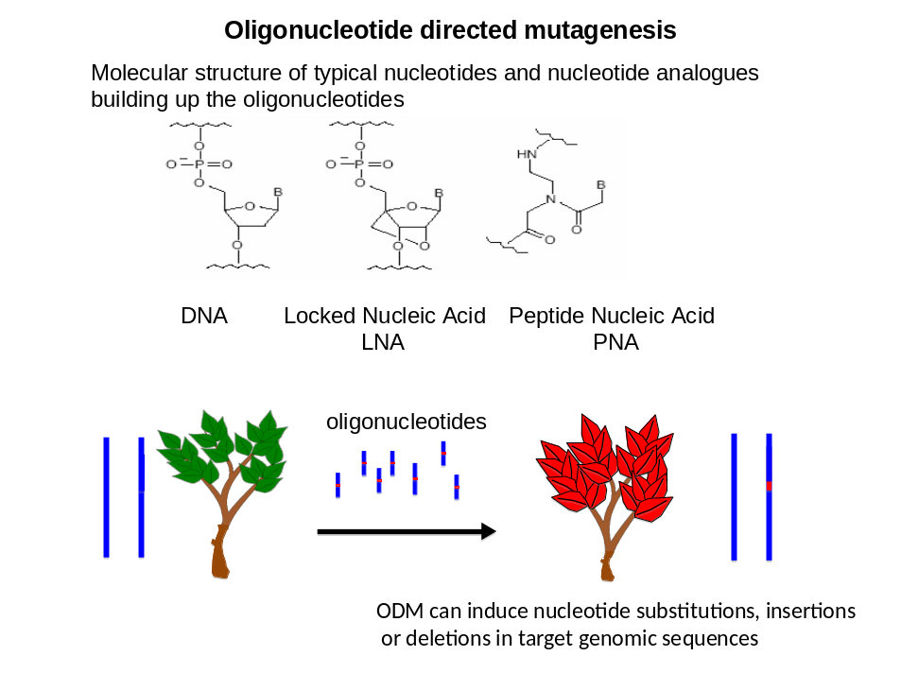

Fig. 1 Oligonucleotide-directed mutagenesis

The top row shows some examples of typical molecules used for oligonucleotide-directed mutagenesis. The bottom row shows the oligonucleotides above the black arrow; short sequences identical to plant genomic sequences are blue; red indicates a small sequence change. The resulting plant on the left (red) stably inherits the change to subsequent generations.

5.1.1 Definition and brief description of the technique based on the current scientific knowledge and current scientific literature

Oligonucleotide directed mutagenesis (ODM) employs oligonucleotides for targeted (site-specific) induction of point mutations.

Oligonucleotides of approximately 20 to 100 nucleotides are delivered to the cells by methods suitable for the different cell types (including electroporation, polyethylene-glycol-mediated transfection, natural uptake). The technique exploits the sequence specific interaction of the oligonucleotide with the resident DNA of the cells, resulting in gene targeting. This directs the attempted genetic modification to a specific region in the DNA or even to a specific base pair. The genetic modification can be the induction of a point mutation or reversion of an existing mutation which may lead to changes in the expression of a gene.

Four different types of oligonucleotides have been used so far:
- single-stranded homologous DNA with a mismatch to the target sequence;
- chimeric oligonucleotides consisting of RNA stretches within single-stranded DNA;
- triple helix-forming oligonucleotides (TFOs) which form relatively stable associations with duplex DNA via Hoogsteen hydrogenbonds (parallel and antiparallel);
- RNA oligonucleotides were recently investigated to induce RNA-mediated, targeted DNA nucleotide sequence changes and RNA-templated DNA repair resulting in point mutations;
- LNA or PNA or any other nucleic acid analogues could also be used.

5.1.2 Application of the technique

The induction of point mutations has been successfully performed in agriculturally important plants including rapeseed, maize, tobacco, rice, and wheat (e.g. herbicide tolerance) and it is being explored in animals including sheep and cattle (e.g. genetic improvement of livestock animals). The technique has been used successfully in bacteria and yeast mainly as a tool to perform basic research on gene expression, regulation and genetic recombination, and in human cells for gene therapy.

5.1.3 Other issues

Potential impacts of the technique
If the oligonucleotide and the experimental protocol are adequately designed, the mutation induced by ODM should be highly specific.

5.1.4 Relevant issues for classification

- Similarity to mutagenesis:
  - Oligonucleotide-directed mutagenesis (ODM) is a form of mutagenesis induced by oligonucleotides.
  - Only oligonucleotides with sequence similarity or analogy to the recipient's genome are used (they may be modified chemically to improve stability).
  - During the application of ODM, modifications are made to the organism's genetic material by the hosts own repair mechanisms.
  - The induced point mutations are site-specific. Similar mutations can occur spontaneously in nature or may be induced by conventional mutagenesis (chemical or radiation).
- Nucleic acids: A majority of experts were of the view that oligonucleotides in this technique cannot be considered as recombinant nucleic acids in the sense of Annex I Part B of the Directive 2001/18/EC or Directive 2009/41/EC. For a minority of experts it is not possible to arrive at this conclusion.

5.1.5 Coverage by GMO legislation

A Annex of Directive 2001/18/EC and Directive 2009/41/EC to which the technique may be attributed

There are two possible interpretations about the coverage of ODM by the GMO legislation (see in particular sections 4.2, 4.3 and 4.4):
1. ODM is not captured by Annex IA Part 1 on the grounds that oligonucleotides introduced into the cell are not recombinant nucleic acid molecules capable of continued propagation (No 1) and they are not heritable material (No 2). Furthermore, the resulting organisms from ODM are captured by Annex IB because the technique entails mutagenesis. Mutagenesis is listed as one of the techniques yielding organisms to be excluded from the application of Directive 2001/18/EC and Directive 2009/41/EC. This represents the view of a majority of experts.
2. ODM is similar to techniques listed in Annex IA, Part 1, because ODM is a recombinant nucleic acid technique that (i) leads to a new combination of genetic material resulting in a heritable change in the DNA sequence (point 1) and (ii) it involves the direct introduction of heritable material prepared outside of the organism (point 2). On this basis, ODM falls under the scope of Directive 2001/18/EC and Directive 2009/41/EC. This represents the view of a minority of experts.

B Concluding remarks for regulation on the status of the technique

● Directive 2001/18/EC/ Directive 2009/41/EC
All experts agree that ODM results in changes in organism that can be obtained with other forms of mutagenesis. They also noted that ODM is expected to generate fewer unintentional changes or effects than those introduced into organisms by irradiation or chemical mutagenesis, which is listed under indent 1 of Annex IB/Annex II Part A "as a technique of genetic modification yielding organisms to be excluded from the Directives". Therefore, ODM is captured by Annex IB/ Annex II Part A. This was a majority opinion.
- Detection
Organisms developed through ODM cannot be distinguished at the molecular level from those developed through “conventional” mutation techniques (using chemicals or ionizing radiations) or through selection in natural populations.

5.2 Zinc Finger Nuclease and related techniques

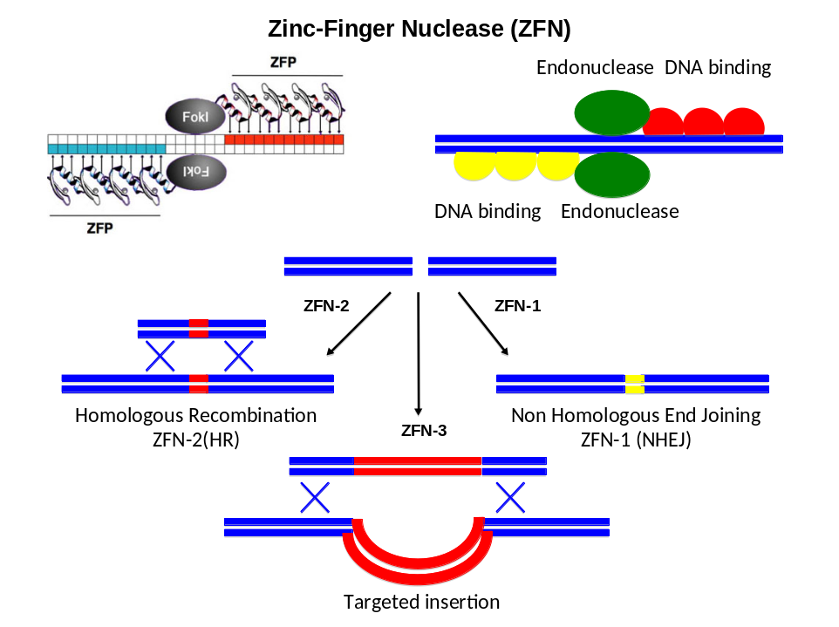

Fig. 2 Zinc Finger Nuclease technique

Schematic representation of the three different ways the ZFN technique may be used (see text for details). Blue bars represent the host double-strand DNA; red bars represent heterologous double-strand DNA; Fokl = restriction endonuclease, the cleavage domains in ZFNs; ZFP = Zinc-finger protein

5.2.0 Introduction

Zinc Finger Nucleases (ZFN) are protein chimeras comprised of a zinc finger based DNA binding domain linked to a DNA cleavage domain introducing a single-strand cut. Zinc Finger domain(s) can be custom-designed to bind to a specific site within a given locus, thereby providing a highly specific targeting tool. Two ZFN proteins with neighbouring targets on opposite DNA strands (see Figure 2) are necessary to produce a DNA double-strand break (DSB). The genes for the ZFN proteins are delivered for instance by electroporation with plasmids or by infection with viral vectors into the cells; Agrobacterium-mediated transfer can also be used in plants. ZFNs are typically expressed transiently from a non-replicating vector (plasmid, virus) however, they may be delivered directly as proteins or as mRNA.

In the cell, the ZFN proteins recognise the target DNA site as a heterodimer and generate a DSB. Depending on the number of zinc fingers in the ZFN, the target DNA site may be (currently) up to 24 nucleotides long. Such a length potentially makes it feasible to target any gene within a eukaryotic genome specifically. The DSBs are capable of triggering the cell’s natural DNA-repair processes: homologous recombination and non-homologous end-joining, thus facilitating site-specific mutagenesis.

As of now, this technique may be used in three different ways, which for practical reasons are designated ZFN-1, ZFN-2 and ZFN-3 in this report. ZFN-1 generates site-specific random mutations by non-homologous end-joining conferring changes of a single or a few base pairs, short deletions and insertions. In ZFN-2, a short homologous repair template is used together with the ZFN-complex, to introduce specific nucleotide sequence changes by homologous recombination. In ZFN-3 a large stretch of DNA (up to several kilobases) with ends homologous to the DNA sequences flanking the DSB site is introduced together with the ZFN-complex. This allows insertions of entire genes at specific locations and ZFN-3 might therefore be used for transgenesis as well as cisgenesis and intragenesis (see section 5.3).

With regard to plants, ZFN techniques have been shown to function in tobacco, Arabidopsis and maize.

ZFN techniques have many applications for humans and animals including gene inactivation, reversion of mutations ("gene repair") and insertion of new genes. In addition, ZFN techniques have been shown to function also in fish, amphibians and invertebrates. The efficiency varies depending on the species.

ZFN techniques are not relevant in prokaryotes for which homologous recombination works and where more cost-effective methods have been established for site-specific mutagenesis. The method works well in yeast, and has potential applications for other eukaryotic microbes although it has not yet been exploited to its full potential.

Instead of ZFN, other nucleases targeting specific sequences of 16 to 22 nucleotides or more are presently being developed and their application explored. These nucleases include an increasing number of engineered meganucleases (homing nucleases from genetic elements; Grizot et al., 2010; Nucleic Acids Res.) and of transcription activator like (TAL) nucleases engineered from transcription-activator-like proteins and a nuclease (Christian et al., 2010; Genetics). What is discussed in this section relating to ZFN-1, ZFN-2, and ZFN-3 similarly applies to the use of these other sequence-targeting nucleases.

5.2.1 Zinc Finger Nuclease-1 (ZFN-1) / Zinc Finger Nuclease-2 (ZFN-2)

ZFN-1 and ZFN-2 are considered together owing to the similarities between the techniques.

5.2.1.1 Definition and brief description of the technique based on the current scientific knowledge and current scientific literature

A Zinc Finger Nuclease-1 technique (ZFN-1) generates site-specific random mutations (changes of single base pairs, short deletions and insertions) by non-homologous end-joining.

During ZFN-1, no repair template is provided to the cells together with the ZFN. The DSB is repaired by non-homologous end-joining which is a natural DNA-break repair mechanism in the cell. This often (though not always) results in a single or a few base substitutions or small localized deletions or insertions. In the case of insertions, the inserted material is derived from the organism’s own genome i.e. it is not exogenous. The DNA end (from the strand break) may also become joined to a completely unrelated site, which results in chromosomal translocation.
B Zinc Finger Nuclease-2 (ZFN-2) generates site-specific the desired point mutation by DNA repair processes through homologous recombination, (specific nucleotide substitutions of a single or a few nucleotides or small insertions or deletions). During ZFN-2, a continuous stretch of DNA is delivered to the cells simultaneously with the ZFN. This template DNA is homologous to the targeted area, spanning a few kilo base pairs (kbp), and overlaps the region of the DSB. The template DNA contains the specific base pair alteration(s) to be introduced into the target DNA or chromosome. The exogenous repair DNA competes with the sister chromatids as a repair template and - with a low frequency - leads to replacement of the original nucleotide sequence. In most studies, the aim has been to replace one or a few bp. There are indications that efficiency of repair decreases where the number of mismatches increases in the template DNA with increasing distance from the DSB. The result is thus comparable with some other site-specific mutagenesis methods.

5.2.1.2 Application of the technique

ZFN-1 and ZFN-2 can be used for targeted random (ZFN-1) or nucleotide-specific (ZFN-2) mutagenesis. In principle, ZFN-1/2 can be applied to any cell line or organism provided there is the possibility to introduce the ZFN proteins or their coding nucleic acids.

5.2.1.3 Other issues

A Potential impacts of the technique
Same as ODM (see 5.1.1.3).

5.2.1.4 Relevant issues for classification

- Transient presence/effect:
Until recently, the approach has been to insert recombinant nucleic acids encoding ZFN into a vector. Provided the construct does not replicate or integrate, its presence in the cell is transient (see section 4.4). In the case of ZFN-2, the repair template is always provided as a specific fragment of DNA. Both the construct and the repair template are transiently present in the recipient cell. The ZFN can also be introduced into the cell as mRNA. It should be noted that recent technical developments allow the ZFN protein to be delivered directly into the cells, thus avoiding the need for DNA recombinant vectors.
- During the application of ZFN-1/ZFN-2, the ZFN encoding nucleic acids give rise to a permanent heritable change owing to a change in the DNA nucleotide sequences. Such modifications to the organism's genetic material are made by the host's own repair mechanisms.
- Heritable material:
With regard to ZFN-2, there was a discussion as to whether oligonucleotides (in this case, the DNA template) constitute heritable material in the sense of the Directives, point on which experts did not agree. (see section 4.3)
- Resulting organism/Offspring:
There was a discussion whether the technique leads to an organism falling within the scope of Directive 2001/18/EC, in particular, if this only depends on whether the GMO offspring does not carry the transgenic construct (see section 4.6).
- Nucleic Acids:
Currently the technique tends to make use of recombinant nucleic acid molecules (vector with genes encoding the two ZFN proteins) or the corresponding mRNAs. Therefore, in accordance with the chapeau of Annex IB of Directive 2001/18/EC and Annex II Part A of Directive 2009/41/EC, the technique can not yield organisms to be excluded from the Directive even if it results in a genetic modification that may happen spontaneously or through other forms of mutagenesis. This conclusion is not valid when the ZFN proteins are delivered directly into the cells (see first bullet under “Transient presence/effect).
- Similarity to mutagenesis:
The same mutations may occur spontaneously or through other forms of mutagenesis (chemical or physical).

5.2.1.5 Coverage by GMO legislation

A. Annex of Directive 2001/18/EC and Directive 2009/41/EC to which the technique may be attributed

- All experts agreed that when the ZFN proteins (concerns ZFN-1) are introduced directly into the cell as a protein, the technique is fully captured by Annex IB (Directive 2001/18/EC) or Annex II Part A (Directive 2009/41/EC) (under which organisms resulting by the listed techniques are excluded from scope of the Directives under certain conditions.
- A majority considers the intermediate organisms containing non-replicative constructs or mRNA are not GMOs. A minority of experts agrees that these organisms, containing nucleic acids encoding ZFN proteins (concerns both ZFN-1 and -2), irrespective of its heritability and its capability of continued propagation, is covered by Annex IA, Part 1 of Directive 2001/18/EC and Annex 1 Part A of Directive 2009/41/EC.
- A majority of experts agreed that in the case of ZFN technique, when ZFN proteins are introduced together with repair template directly into cells, the technique is also fully captured by the Annex IB (Directive 2001/18/EC) or Annex II Part A (Directive 2009/41/EC) and therefore the resulting organisms are out of the scope of the Directives through the exclusions that these Annexes provide. A majority of experts were of the view that oligonucleotide templates in this technique cannot be considered as recombinant nucleic acids in the sense of Directive 2001/18/EC or Directive 2009/41/EC. For a minority of experts it is not possible to arrive at this conclusion.
- All experts agree that ZFN-1/ZFN-2 results in changes in organism that can be obtained with other forms of mutagenesis. For a majority of experts organisms produced by ZFN-1/ZFN-2 are "to be excluded" in line with Annex IB of Directive 2001/18/EC and Annex II Part A of Directive 2009/41/EC. When recombinant nucleic acid molecules are used (the prevalent technique), for a minority of experts, however, the Directive is clear that organisms produced by ZFN-1/ZFN-2 cannot be excluded on this basis since they do not meet the conditions of the chapeau of Annex IA part 2 of Directive 2001/18/EC and Annex II Part A of Directive 2009/41/EC.

B Concluding remarks for regulation on the status of the technique

● All experts agreed that the organisms resulting from ZFN-1/ZFN-2 are similar to organisms resulting from mutagenesis already identified for exclusion under Annex IB of Directive 2001/18/EC or Annex II Part A of Directive 2009/41/EC. They also noted that these techniques are expected to generate fewer unintentional changes or effects than those introduced into organisms by irradiation or chemical mutagenesis.
● There is a general agreement that the resulting organism from the use of ZNF-1/ZFN-2 is a GMO, but it should be excluded from the Directive. Some experts considered that ZNF-1/ZFN-2 are already captured by Annex IB and thus excluded from the Directive (see above). Other experts feel that exclusion could be achieved by specific inclusion of ZNF-1/ZFN-2 in Annex IB of Directive while further experts are of the opinion that this could be done by clarifying that "mutagenesis" actually includes ZNF-1/ZFN-2.
- Detection
Organisms developed through ZFN-1/ZFN-2 cannot be distinguished at the molecular level from those developed through “conventional” mutation techniques (using chemicals or ionizing radiations) or selection from natural diversity.
5.2.2 Zinc Finger Nuclease-3

5.2.2.1 Definition and brief description of the technique based on the current scientific knowledge and current scientific literature

Zinc Finger Nuclease-3 technique (ZFN-3) targets delivery of transgenes (insertions) by homologous recombination.

DNA fragments or gene cassettes up to several kbp in length can be inserted precisely to a desired site in the genome or a gene. In practice, a recombinant DNA molecule is constructed in which the DNA fragment or the gene cassette of interest (donor DNA) is sandwiched between stretches of DNA that are homologous with the DNA sequences flanking the DSB site. Donor DNA can come from any species and it is delivered to the cell, along with the ZFN, and it is targeted to the desired site of the genome and inserted into the DSB site.

5.2.2.2 Application of the technique

There has been an emphasis to develop and use the technology on human cells although it has also been seen as a powerful tool for genetic engineering of animals. Furthermore, potential applications of the technique include targeted gene addition, replacement and trait stacking in plants. As demonstrated recently (reference), it is a breakthrough to insert DNA into a specific site in the plant (e.g. maize) genome. Previously, this has not been possible.

5.2.2.3 Relevant issues for classification

- Nucleic acids and recombinant nucleic acids:
New combinations of genetic material are introduced into the cell when the donor DNA fragment is integrated into the recipient genome and is continuously propagated.
- Similarity to self-cloning:
The technique may meet the criteria of self-cloning when:
  - the donor DNA (or template of the synthetic DNA) originates from an organism of the same species as the recipient or from a phylogenetically closely related species;
  - the recombinant vector has an extended history of safe use in the particular micro-organism;
  - the resulting micro-organism is unlikely to cause disease to humans, animals or plants, (see also relevant comments on cisgenesis).

5.2.2.4 Coverage by GMO legislation

Annex of Directive 2001/18/EC and Directive 2009/41/EC to which the technique may be attributed

- All experts agreed that ZFN-3 is covered by Annex IA, Part 1 of Directive 2001/18/EC since it is a recombinant nucleic acid technique involving the formation of new combinations of genetic material. Organisms developed through this technique therefore fall within the scope of the Directive.
- The technique may in some cases meet the criteria of self-cloning (see 5.2.2.3 above) as described in Annex II, Part A(4) of Directive 2009/41/EC and when that is the case it may be considered to fall outside the scope of Directive 2009/41/EC.

5.2.2.5 Other issues

Potential impacts of the technique
Same as cisgenesis, intragenesis and currently used techniques of genetic modification, depending on the transferred gene

B. Concluding remarks for regulation on the status of the technique

- While the ZFN-3 technique generally is within the scope of Directives 2001/18/EC and 2009/41/EC, in some cases it could meet the criteria of self-cloning as described in Annex II, Part A of Directive 2009/41/EC and when that is the case it may be considered as falling outside the scope of Directive 2009/41/EC.
- Detection
Detection and identification of organisms modified by ZFN-3 technology are possible through the amplification based methods (PCR) currently used for GMO detection, with the prerequisite that prior adequate DNA sequence information on the introduced modification is available.

5.3 Cisgenesis and Intragenesis

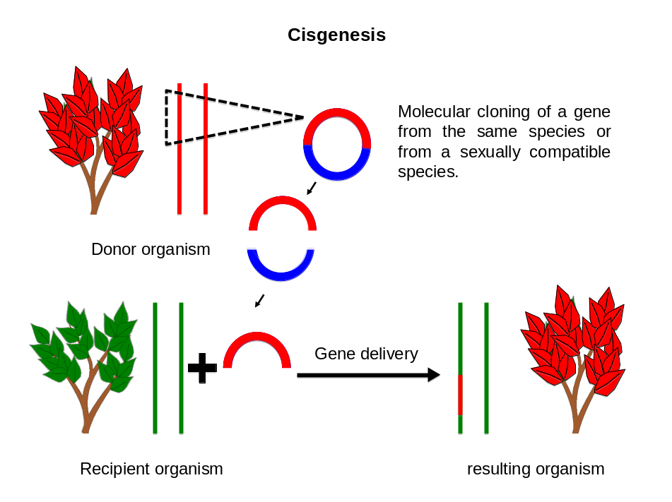

Fig. 3 Cisgenesis

Schematic representation of cisgenesis. Blue: nucleic acid from the vector; red: DNA sequences from the donor plant; green: DNA sequences from the recipient plant. Donor and recipient organism belong to species which are sexually compatible.

5.3.1 Definition and brief description of the technique based on the current scientific knowledge and current scientific literature

Cisgenesis is genetic modification of a recipient organism with a gene (cisgene) from a crossable - sexually compatible – organism (same species or closely related species). The gene includes its introns and its flanking native promoter and terminator in the normal sense orientation.

Cisgenic plants can harbour one or more cisgenes, but they do not contain any parts of transgenes or inserted foreign sequences. To construct cisgenic plants the same molecular biology techniques used for construction of transgenic organisms may be used. Genes must be isolated, cloned or synthesized and transferred back into a recipient where stably integrated and expressed.

Sometimes the term cisgenesis is also used to describe an Agrobacterium-mediated transfer of a gene from a crossable - sexually compatible – plant. If T-DNA borders remain in the resulting organism after transformation, the technique is referred further in the text as cisgenesis with T-DNA borders.

Intragenesis is a genetic modification of a recipient organism that involves the insertion of a reorganised, full or partial coding region of a gene frequently combined with a promoter and/or terminator from another gene (intragene) of the same species or a crossable species. These may be arranged in a sense or antisense orientation compared to their orientation in the donor organism.

5.3.2 Application of the technique

Often, the genome of an undomesticated line of a plant species may be a source of a valuable gene, e.g. in determining disease resistance. In order to transfer such a gene of interest to a domesticated plant line of that species, e.g. of a high yielding variety, it is necessary to perform a consecutive line of several crosses and backcrosses. Thus it may take 10 - 15 years (for annual plants) or more to develop a cultivar possessing the desired gene from the non-adapted plant by traditional breeding. The application of cisgenesis would condense this otherwise lengthy process. In addition, cisgenesis and intragenesis prevents so-called linkage drag of unwanted or undesirable genes, which is often observed in traditional breeding. Cisgenesis and intragenesis are currently mainly applied in plants, however the technique may be similarly used in animal breeding. According to the experts current commercial applications relate more frequently to intragenesis than to cisgenesis.

5.3.3 Other issues

A. Potential impacts of technique
Cisgenesis may lead to the disruption of existing ORFs or creation of new one(s), due to random insertion of the gene in any part of the genome, or over expression of a native (cis-)gene. This could lead to altered biochemical properties, allergenicity, and/or toxicity. However, similar effects can sometimes take place in traditional breeding or via normal biological processes.

5.3.4 Relevant issues for classification

- Similarity to currently used techniques of genetic modification: The random insertion of a cisgene or intragene could induce alterations in the plant genome in a similar manner to transgenes, e.g. the creation of new open reading frames (ORFs) and the disruption of existing genes. There is also the possibility of multiple insertions and over-expression of the inserted gene(s).
- Similarity to traditional breeding: Cisgenesis yields organisms similar to those obtained by traditional breeding techniques or via normal biological processes of reproduction. This is also the case with cisgenesis with T-DNA borders, where the T-DNA border sequence is identical to or has high similarity (≥85% identity) to DNA sequences already present in the genome of the plant species.

5.3.5 Coverage by GMO legislation

A Annex of Directive 2001/18/EC and Directive 2009/41/EC to which the technique may be attributed
- All experts concluded that cisgenesis and intragenesis are covered by Annex IA, Part 1 of Directive 2001/18/EC. Organisms developed through these techniques therefore fall within the scope of Directive 2001/18/EC.
- All experts indicated that cisgenesis is similar to self-cloning. As regards cisgenesis with T-DNA border sequences, all experts agreed that if sequences identical to T-DNA border sequences or with high similarity (≥85% identity) are already present in the genome of the same or sexually compatible species, the resulting organism may be considered as equivalent to organisms resulting from self-cloning on the basis that these modifications could also be obtained by traditional plant breeding techniques, or take place via normal biological processes of reproduction. If the T-DNA borders are not present in the same or sexually compatible species, all expert agreed that the organism cannot be obtained by traditional breeding and the technique cannot be considered as self-cloning.
- All experts agreed that intragenesis cannot be considered as yielding GM organisms equivalent to organisms resulting from self-cloning, and such organisms cannot be obtained by traditional breeding. Micro-organisms developed through self-cloning are covered by Annex II, Part A(4) of Directive 2009/41/EC and are thereby excluded from the scope of Directive 2009/41/EC. This exclusion only applies where “… the resulting micro-organism is unlikely to cause disease to humans animals or plants". It similarly applies to animal and plant cells in culture.

B Concluding remarks for regulation on the status of the technique
- The technique may in some cases meet the criteria of self-cloning as described in Annex II, Part A of Directive 2009/41/EC and when that is the case it may be considered as falling outside the scope of Directive 2009/41/EC. More specifically, all experts considered that cisgenesis and cisgenesis with T-DNA borders (ONLY with border sequences identical or highly similar (≥85% identity with sequences) already present in the same or sexually compatible species) may be considered as yielding organisms equivalent to those resulting from self-cloning and therefore that could be considered as out of the scope of Directive 2009/41/EC.
  - The co-legislators treated self-cloning differently in Directive 2001/18/EC and in Directive 2009/41/EC. Assuming that the logic for having excluded self-cloning from Directive 2009/41/EC was that it yields micro-organisms with modifications that could also be obtained by traditional breeding, all experts wondered about the justification for not excluding them from Directive 2001/18/EC.
  - Detection
The introduction of cisgenes and intragenes into plants can be specifically detected if a sufficient part of the sequence of the insert as well of the adjacent sequence is known.

5.4 Grafting

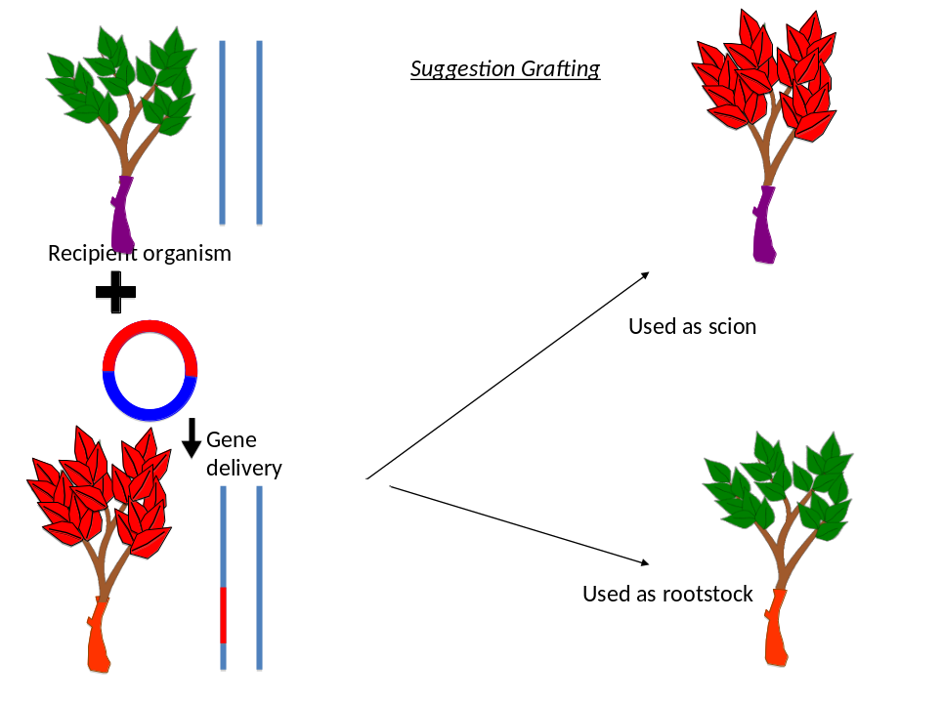
Fig. 4 Grafting
Schematic representation of grafting using both conventionally bred and GM plants. Top left: a conventionally bred plant line; bottom left a transgenic plant line derived thereof; right two different chimera, where either the transgenic plant line or the conventionally bred plant line (bottom) are used as root stock or scion, respectively.

5.4.1 Definition and brief description of the technique based on the current scientific knowledge and current scientific literature

Grafting is an ancient technique used to combine desired traits of two different plants. It is a method whereby a vegetative top part (the graft or scion) of one plant is attached to a rooted lower part (the rootstock) of another plant. A callus develops in the junction area and the callus cells become differentiated into the same type of cells as those in the vicinity. In particular, the vascular systems of both parts are connected, which allows the transfer of sap between the rootstock and the graft. Although different parts of the plant consist of genetically distinct cells, the whole plant forms a single organism ('chimera’).

Two possibilities were considered:
- Grafting a non-GM scion onto a GM rootstock;
- Grafting a GM scion onto a non-GM rootstock.

Proteins and RNAs can conceivably be transported from the rootstock through the graft junction and into the scion and vice versa. This can affect the gene expression and phenotype of the upper (or lower) part of the plant and is independent of whether the rootstock (or the scion) is genetically modified or not. Although transport of macromolecules may occur from the lower part of the GM plant (rootstock) to the non-GM scion, these are not transmitted to the next generation via the seeds as they do not lead to genetic modification.

5.4.2 Application of the technique

Grafting has been extensively applied to fruit trees, but grafting is also used on for example vegetables, especially within the genera Cucurbita and Solanum.

Cultivation of grafted vegetables has been practiced in many countries for several decades and is increasing in Europe. Watermelon and tomato are the two major vegetables where grafting is important worldwide. Grafting is also routinely used with other vegetables such as cucumber, melon, oriental melon, greenhouse squash, eggplant, grapevine and pepper. One of the major advantages of using grafted plants is e.g. to utilize the resistance of rootstocks to certain soil-borne diseases like Fusarium wilt in cucurbits and tomato, Phytophthora disease in pepper, and virus in tomato. Watermelons, for example, are grafted onto rootstocks of squash and gourd varieties that are resistant to Fusarium and other soil-borne diseases that would otherwise devastate the watermelons.

5.4.3 Other issues

A Potential impacts of technique
- Risk assessment considerations: Where a non-GM scion is grafted onto a GM rootstock, the scion (including any tissue or organisms derived from it) is considered non-GM since no change in coding sequence is present in the scion. However, there may be a change in gene expression or in protein/metabolite composition in the scion due to the transport of molecules across the graft. For environmental and food/feed safety purposes, the risk assessment should consider the entire plant and take into account potential effects of the GM rootstock on the scion. The assessment should take into account the consideration that the same GM rootstock may be used in combination with different non-GM scions, or that the same non-GM scion may be used in combination with different GM rootstocks. If effects on the scion are identified conditions may be posed on the use of the GM rootstock or the whole plant. The above-mentioned considerations would also apply to the case of a non-GM rootstock combined with a GM scion.
- Following risk assessment of a GM rootstock, specific conditions can be taken into consideration on the use of the non-GM scion on a case-by-case basis, depending on the nature of the modification of the GM rootstock and its impact on the non-GM scion.

5.4.4 Relevant issues for classification

    - The chimeric plant consists of a GM part (e.g. GM-rootstock), fused to a non-GM part (e.g. non-GM scion).
- Where a non-GM scion is grafted onto a GM rootstock, the whole plant is a chimera in which the flowers, seed, fruits, and parts of the scion like the leaves are non-GM. However, where the rootstock entails e.g. a woody crop, suckers may grow from the rootstock and produce flowers and seeds (fruits). These seeds or fruits are by definition GM.
- Where a GM scion is grafted onto a non-GM rootstock, the whole plant is a chimera in which the flowers seeds, fruits, and parts of the scion like the leaves are GM.
- In some cases, grafting could be used as a tool to obtain an effect through RNA interference. In this case, the conclusions of the WG for RNA-dependent DNA methylation should also be taken into account (see point 5.4).

5.4.5 Coverage by GMO legislation

    - There is a general agreement that the whole plant, which is a chimera, falls within the scope of Directive 2001/18/EC.
    - Where the fruit/seed/offspring are being considered and where a non-GM scion is grafted onto a GM rootstock, the resulting fruit/seeds/offspring derived from the scion do not fall under the scope of Directive 2001/18/EC.
    - Where a GM scion is grafted onto a non-GM rootstock, the resulting fruit/seeds/offspring fall under the scope of Directive 2001/18/EC.
    - Detection
The transgenic part of the chimera can be specifically detected if a sufficient part of the sequence of the insert as well of the adjacent sequence is known. As the DNA sequence of the non-GM scion is not modified, detection and identification of the GM rootstock on the basis of the harvested product (part of the non-GM scion) is currently not possible and is very unlikely to be developed in the near future.

5.5. Agro-Infiltration

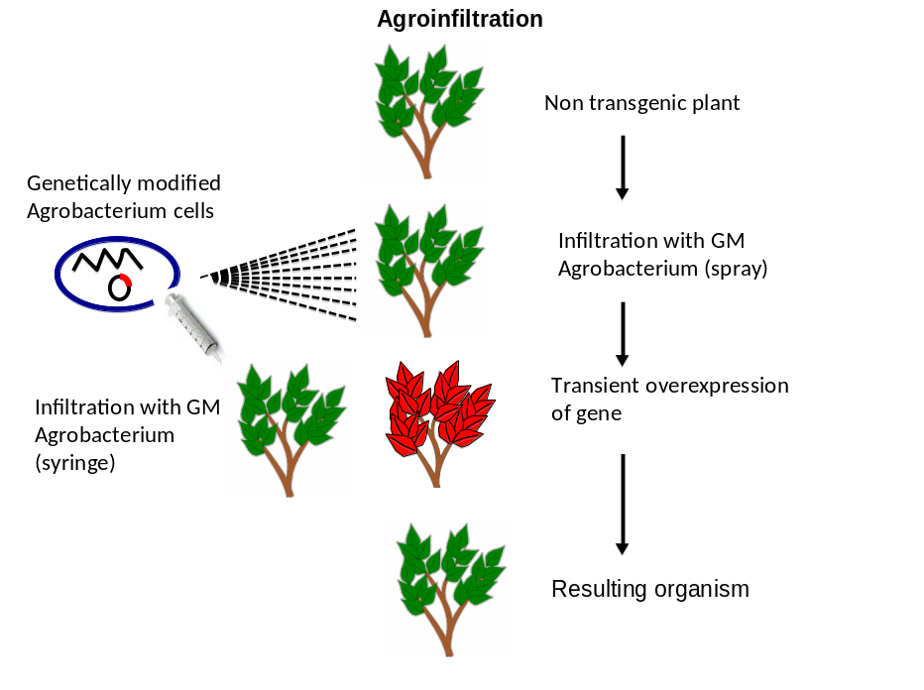

Fig. 5 Agro-infiltration:

Schematic representation of agro-infiltration. The syringe and the spray indicate two alternative ways of application. The black arrows on the right indicate the steps in the procedure. The transient nature of agro-infiltration is reflected by the green plant at the bottom of the figure, where the red leaf colour has disappeared. Note that only very few, if any, plant cells at the site of infiltration are transformed, thus the red plant here does not indicate that the plant is transgenic, but the transient expression of the infiltrated gene.

5.5.1 Definition and brief description of the technology based on the current scientific knowledge and current scientific literature

Bacteria in the genus Agrobacterium, and especially A. tumefaciens, have the capability to transfer a part of their DNA (the so called T-DNA) into the nucleus of plant cells. Agro-infiltration aims to use Agrobacterium to inject large numbers of foreign DNA molecules into the plant cells, so that they can be used as templates for the cell's transcription/translation machinery with no need for replication or integration.

To perform agro-infiltration, plant tissues are infiltrated (in vivo or ex vivo) with a liquid suspension of Agrobacterium sp. containing a genetic construct in order to promote localised expression of a given genetic material. The benefits of agro-infiltration over stable transformation are speed, convenience, and the high level of expression usually reached.

In some in vivo applications the T-DNA may contain replicative material (in the form of either fully functional virus genome, or as “replicons" not able to spread within the plant) in order to obtain expression in parts of the plant other than the infiltrated area or to further increase the expression level.

5.5.2 Application of the technique

Depending on whether or not the plant tissues contain germline cells/tissues, two types of agro-infiltration can be distinguished:
- Agro-infiltration “sensu stricto”:
Non-germline tissues (typically, leaf tissues) are agro-infiltrated in order to obtain localised expression, for instance:
- to obtain large amounts of a given protein expressed in plant tissues;
ii. to test the phenotypic effect of a given gene product in plants (for instance, when an avirulence gene or similar factor is expressed, the possibility to rapidly screen plant populations for the presence of the cognate resistance gene has potential applications in the breeding industry).
- "Floral dip":
Flowers or inflorescences containing germline cells are agro-infiltrated in order to obtain stable transformation of some embryos that can then be selected at the germination step. Nowadays this is the technique of choice to transform the model plant Arabidopsis thaliana, and it can also be used for other species in the same family (including rapeseed, cabbage, mustard etc).

Agro-infiltration takes place under conditions of containment. Progeny, if produced, is grown in a greenhouse and may be grown outdoors in some cases, for instance when agro-infiltration is used as a tool in the process of selecting commercial varieties with a given phenotype.

5.5.3 Relevant Issues for classification of the resulting plant

- The agro-infiltrated plant tissues contain Agrobacterium cells in their intercellular space. The Agrobacterium cells do not enter the plant cells. Generally they remain localised in the infiltrated area, where they survive and can even multiply since this situation is similar to their ecological niche. Some movement of the bacterial cells to non-infiltrated areas of the plant (including the reproduction organs) is conceivable but not expected.
- These Agrobacterium cells contain a plasmid with a T-DNA region in which, typically, foreign DNA has been inserted by biotechnological techniques. The bacteria actively deliver the T-DNA into the plant cells.
- The T-DNA accumulates but does not replicate in the plant cell. It undergoes nuclear transcription and the derived mRNA undergoes translation. Integration into the genome is a rare event that can occur in a small number of cells in each infiltrated area: the selection of these rare events to regenerate stable transformants is not the aim here except in the case of floral dip. In the unlikely event that T-DNA is delivered to germline cells, in non-infiltrated areas of the plant integration into the genome of a germinal line could occur. Again, while this is conceivable, it is highly unlikely (it has never been observed to date).
- The nature of the foreign DNA inserted within the T-DNA region may have a bearing on its ability to replicate and /or whether it integrates into the plant genome, and if it occasionally does, with what frequencies. For instance, it is the aim of applications where the T-DNA contains replicative material (such as viruses) to achieve expression in the entire plant.
- In most applications, the plant (or plant tissues) subjected to agro-infiltration sensu stricto, is not allowed to set seed, but is destroyed at the end of the procedure (purification of the expressed protein).
- Sometimes progeny could be produced when agro-infiltration is used in the process of screening plant populations for a desired phenotype (i. e. sensu stricto).
- In the case of floral dip a progeny is generally produced and selected for stable integration of the T-DNA in its genome.

5.5.4 Coverage by GMO legislation

A Annex of Directive 2001/18/EC and Directive 2009/41/EC to which the technique may be attributed

- The recombinant Agrobacterium. It is a GMM and falls within the scope of Directive 2009/41/EC (Annex I, Part A) when it is present.
- The plants that were subjected to agro-infiltration. Integration of the foreign DNA into the genome of a few plant cells of the infiltrated area is a rare event that needs to be examined on a case-by-case basis. Furthermore, cells in which T-DNA integration into the genome has occurred will not be selected for the regeneration of entire plants (even in the case of floral dip, this selection process occurs in the following generation). On this basis, there was a divergence of opinion among the experts as to whether plants subjected to agro-infiltration should formally be considered to fall under the scope of the Directives. However all experts agreed that these plants fall under the scope of Directive 2009/41/EC since they contain GMMs (see above).
- The progeny of the plants subjected to agro-infiltration “sensu stricto”. Plants derived from lines where the absence of a stably integrated event into the genome is supported by relevant data, should be considered as falling outside the scope of Directive 2001/18/EC.
- The progeny of the plants subjected to “floral dip”. Since floral dip is actually designed to produce plant lines with stable integration events, the progeny lines that are shown to harbour a stable integration event fall clearly within Annex IA, Part 1 of Directive 2001/18/EC.

B Concluding remarks for regulation on the status of the technique

- It was underlined by some experts that agro-infiltration is just one amongst several techniques used to introduce DNA into a few cells of a pluricellular organism in order to obtain localized expression of a foreign DNA. Elements of the opinion above could also be helpful to assess these techniques.
- The recombinant bacterial vector and the progeny of the plants subjected to floral dip clearly fall within the scope of Directive 2009/41/EC (Annex I, Part A) and Directive 2001/18/EC (Annex IA, Part 1) respectively. The experts had divergent opinions regarding the status of the agro-infiltrated plants with regard to Directive 2001/18/EC (exclusion or inclusion on the basis of a few isolated cells usually bound for destruction), but agreed that the large bacterial population hosted in its intercellular space fall within the scope of Directive 2009/41/EC (Annex I, Part A). In situations where the agro-infiltrated plants produce a progeny, this progeny should be considered to fall outside the scope of Directive 2001/18/EC once the absence of a stable integration event is shown.
- Detection
If the constructs introduced into plants by agro-infiltration are not replicated and/or integrated, their presence is transient and can be detected only in the agro-infiltrated plant itself. These DNA fragments will not be transferred to the next generation so they cannot be detected or identified in the progeny plant and the products derived thereof. Detection and identification of such products from agro-infiltration or from agroinoculation is therefore not possible. Detection and identification of agroinfiltrated plants and progeny plants that contain stably inserted fragments is possible with the same methodologies that are currently developed and used for GMO detection, which also implies that adequate information needs to be available.

In the case of floral dip, the aim is to select for stable integration into the germline, leading to a genetically modified plant, which means that detection and identification are possible with the methods currently available for GMO detection (PCR), and also implies that adequate information needs to be available.

5.6 RNA-dependent DNA methylation (RdDM)

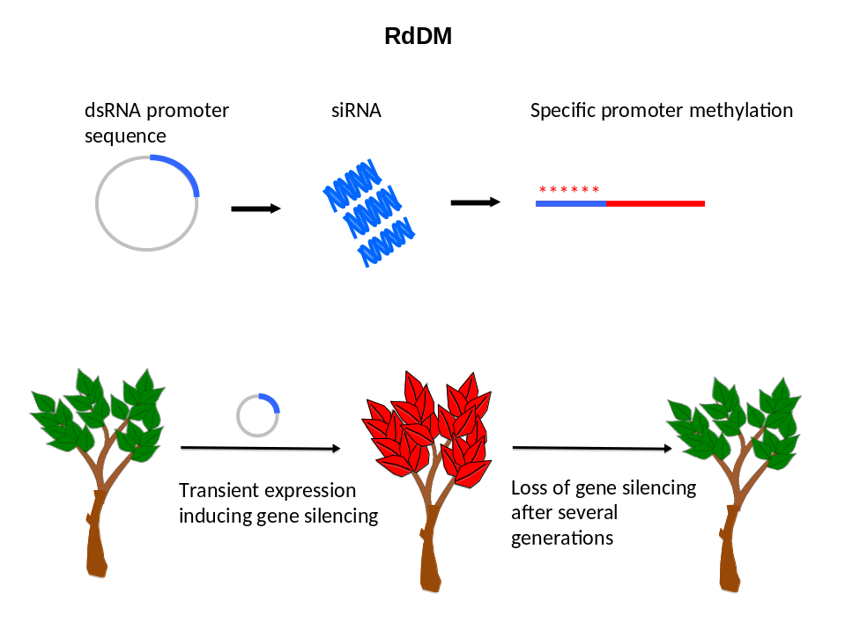
Fig. 6 RNA-dependent DNA methylation

Schematic representation of RNA-dependent DNA methylation. SiRNA can be introduced via a vector (top left), or introduced directly. Specific methylation of plant genes is indicated by asterisks above the DNA sequence. The red plant in the bottom indicates the (transient) silencing of plant. This does not necessarily mean that the plant is transgenic.

5.6.1 Definition and brief description of the technique based on the current scientific knowledge and current scientific literature

RdDM is a technique that uses the effect of small RNA sequences e.g. micro RNA (miRNA) or small/short interfering RNA (siRNA) to alter gene expression through methylation of specific DNA sequences without changing the nucleotide sequence itself (epigenetic change). The purpose could be to shut down expression of specific genes. This gene silencing obtained by the methylation can be inherited through some generations, but will eventually disappear.

The mechanisms by which the DNA methylation and eventually the gene silencing takes place are part of a complex and naturally occurring mechanisms that organism use in their cell regulation.

Gene silencing through DNA methylation can be accomplished in a cell or in an organism by introducing a gene which, once transcribed, gives rise to the formation of double stranded RNAs (dsRNA) and further into small interfering RNA. If these interfering RNA molecules share homology with a promoter region, they can specifically induce methylation resulting in the silencing of the gene regulated by the promoter. This technique allows for highly targeted gene silencing. DNA methylation patterns can be maintained, even after clearance of the initially new inserted gene e.g. due to segregation. However the effect will decrease through subsequent generations and will eventually fade out restoring the original expression of the gene(s) involved.

5.6.2 Application of the technique

In mammalian cells, nematodes and flies, RdDM can be induced by direct introduction of double stranded RNAs (e.g. by liposomes or naked siRNA covalently conjugated with protein).

In contrast, RdDM in plants is usually established by transformation with a DNA construct that encodes hairpin RNAs. For the purpose of the further discussion below certain scenarios can be envisaged:
- Scenario 1): the RdDM is accomplished by insertion of DNA that contains new combinations and that are inherited to the next generation. The resulting organism contains this new DNA and also the new methylations and expression pattern.
- Scenario 2): the RdDM is accomplished by insertion of DNA that is capable of continued propagation but only present in the intermediate organisms. The resulting organism, however, is free of this new DNA by segregation but still contain the new methylations which eventually fades off.
- Scenario 3): the RdDM is accomplished by the insertion of DNA or RNA that are not capable of continued propagation. The resulting organism is free of this new DNA/RNA but contain the new methylations.

A possible limitation of the technique in some applications may be that the epigenetic changes fade out and in that sense the duration of the effect is unpredictable over time. Changes over generations are expected to last longer in plants than in animals.

5.6.3 Relevant Issues for classification

- Similarities to natural processes: DNA methylation leading to changes in gene expression and phenotype can also occur naturally.
- Intermediate organism and resulting organism: both the insertion of the DNA or RNA resulting in RdMD can be accomplished in different ways (e.g. direct/indirect, with/without vectors involved) and the resulting organisms can be selected in different ways (e.g. with/without inserted DNA). All these factors can influence on the interpretation on the GMO status of the intermediate as well as the resulting organisms and therefore lead to many different views from the experts (se also 4.6 offspring section).

5.6.4 Coverage by GMO legislation

A Annex of Directive 2001/18/EC and Directive 2009/41/EC to which the technique may be attributed

All experts agreed that the technique used in scenario 1 is covered by Annex IA, Part 1 of Directive 2001/18/EC and Annex I Part A or Directive 2009/41/EC and the resulting organisms are GMOs.

All experts also agree that the new methylation itself is not regulated by the Directives since methylation of nucleotides is not considered as an alteration of the genetic material in the sense of the Directives. Therefore, for most of the experts the resulting organisms in scenario 2 and 3 is not covered by Annex 1A, Part 1 of Directive 2001/18 or Annex I Part A or Directive 2009/41/EC because neither of these organisms (with the new methylation) contains any heritable changes in nucleotide sequences. This conclusion is reached even if the intermediate organisms are considered GMOs. The arguments for this conclusion are related to the discussion about transient presence and offspring in chapter 4.4 and 4.5.

A majority of experts considered that intermediate organisms (scenarios 2 and 3) do not fall under the definition of GMO of either Directives if the RNA is directly delivered into the cell without being able to replicate. This was based on the grounds that the selected offspring organism does not contain the inserted gene coding for siRNA and no heritable changes in nucleotide sequences are created. The resulting organisms are thus not GMOs.

A few experts considered that if the intermediate organism is considered a GMO the resulting organism is also a GMO in the sense of the Directive. This was based on the ground discussed in the section on GMO offspring.

All experts agreed that the resulting organism (e.g from scenarios 2 and 3), not containing the inserted gene coding for RNAi and having no heritable changes in nucleotide sequences, should logically be outside the scope of the Directives due to the fact that the resulting organisms are comparable to organisms obtained with natural processes.

B Additional remarks for regulation on the status of the technique

The current and future status of the technique depends on the interpretation of the legislation as regards the use of intermediate organisms considered GMOs.

5.6.5 Other issues

A Potential impacts of the technique
Since RdDM-associated transcriptional silencing is apparently influenced by the local surrounding genomic condition of the target promoter locus, reduction of promoter activity may significantly vary among the endogenous promoters of interest, ranging from no reduction to an almost complete knockdown level by the effects of the surrounding genomic sequences.

A possible limitation of the technique may be envisioned in the fact that the epigenetic changes are unstable and in that sense unpredictable over time.

B Concluding remarks

- The current and future status of RdDM depends on the interpretation of the legislation as regards the use of intermediate organisms considered GMOs.
- Detection

The characteristics (phenotype and methylation) can be used for identification only as long as the effect from earlier generations continues.
5.7 Reverse breeding

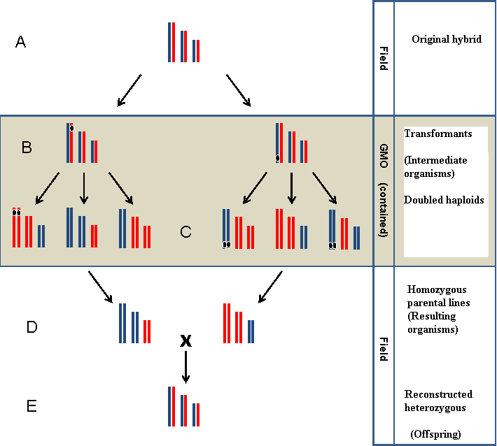
Fig. 7 Reverse Breeding
Schematic explanation of the steps involved in reverse breeding. For details see text.

5.7.1 Definition and brief description of the technology based on the current scientific knowledge and current scientific literature

Reverse breeding allows to produce specific F1 hybrids in a much shorter timeframe and ambient numbers in comparison with conventional plant breeding techniques. In reverse breeding (Fig. 7), an individual heterozygous plant is chosen for its elite quality (Fig. 7, A), and, subsequently, homozygous parental lines are derived from this plant (Fig. 7, D), which upon crossing, can reconstitute the original genetic composition of the selected heterozygous plant (Fig. 7, E) from which the lines were derived.

During reverse breeding, a genetic modification step is employed to suppress recombination during meiosis. However, the final heterozygous plants (and their homozygous parental lines) are non-transgenic (devoid of any new DNA).

To obtain the homozygous parental lines the following steps are taken:
- First, in cells derived from the chosen heterozygous plant, meiotic recombination is suppressed through RNAi (RNA interference)-mediated down-regulation of genes involved in the meiotic recombination process. The RNAi construct is integrated into one chromosome of the cells, (Fig. 7, B).
- The next step is regeneration of these cells into plants (Fig. 7, C). During flowering of this plant with suppressed recombination, haploid microspores (immature pollen grains) are formed.
- The genomes of these haploid spores will subsequently be doubled upon specific treatments. The diploid microspores can eventually develop into embryos and subsequently into homozygous plants (so-called doubled haploids), the homozygous parental lines.

Crossing appropriate pairs of those homozygous plants (Fig. 7, D) will create the desired heterozygous genotype (Fig. 7, E). Using homozygous parental lines for the cross that do not contain the transgenic RNAi-constructs ensures that the resulting final heterozygous plants are non-transgenic (Fig. 7, E). This plant breeding approach offers advantages over existing methods in that in principle any heterozygous plant can now be commercially exploited through reconstitution of suitable parental lines.

5.7.2 Application of the technique

Reverse breeding allows breeders to produce specific F1 hybrids in a much shorter timeframe, in comparison with conventional plant breeding techniques. Furthermore, it provides more flexibility in combining desired traits in a heterozygous setting.

5.7.3 Relevant Issues for classification

- Resulting organism and GMO offspring: following suppression of meiotic recombination, GM (containing the gene for RNAi production) and non-GM doubled haploid plants are generated. Screening is performed to use only non-GM doubled haploids for crosses (which can result in the final hybrids which are the same as the original plant) and on this basis what should be considered non-GM.

5.7.4 Coverage by GMO legislation

A Annex of Directive 2001/18/EC and Directive 2009/41/EC to which the technique may be attributed

- All experts agreed that the specific step where RNAi-mediated suppression of recombination is performed, gives rise to an intermediate organism falling within the scope of Directive 2001/18/EC according to Article 2 and Annex IA, Part 1 of this Directive, and also Directive 2009/41/EC provided it is a microorganism.
- All experts agree that no alteration has been made in the resulting organism (the homozygous parental lines, Fig. 7, D, selected not to carry the genetic modification) and their offspring (Fig. 7, E): are non-GM plants and therefore may be considered as outside the scope of Directives 2001/18/EC and 2009/41/EC.

B Concluding remarks for regulation on the status of the technique

The resulting plants and their offspring are not GM and therefore may be considered as not within the scope of Directives 2001/18/EC and 2009/41/EC on the following grounds:
- The genetic material of the resulting organisms and their offspring have never contained any inserted foreign DNA;
- the genetic composition of the offspring is the same as the original organism or plant material; and
- the resulting organisms and their offspring can be obtained by traditional breeding techniques.
This interpretation is only valid on the condition that only non-GM homozygous plants (doubled haploids) are chosen after the genetic modification step, in order to perform crosses to obtain the desired hybrids.

Detection
Detection is not possible as the end-products of reverse breeding are free of genetic modification-related sequences.

5.8 Synthetic Genomics

5.8.1 Definition and brief description of the technology based on the current scientific knowledge and current scientific literature

Synthetic genomics is a field within synthetic biology that may include techniques of genetic modification. It involves the synthesis of stretches of DNA molecules and their combination into functional larger synthetic DNA molecules which are then transferred into a recipient structure. The synthesis of building blocks enables the easy introduction of changes into the genetic material, including mutations (exchanges, deletions and insertions of specific nucleotides), gene fragments or complete genes including those without any natural template.

Synthetic genomics also paves the way for the introduction of redesigned or newly designed combinations of biological parts that do not necessarily exist in nature and that, for instance, enable the reconstruction of new biological pathways. Alternative genetic codes that are composed of chemically modified nucleic acids ("xeno nucleic acids") and not currently found in life forms could also be used (field called Xenobiology), emphasizing that synthetic genomics merges with other fields of synthetic biology.

Given the fact that synthetic genomics (and more generally synthetic biology) is a fast-evolving field with a potential for very new developments as compared to what can be achieved with gene modification techniques currently listed in the Directives, the WG felt that the subject was too broad to discuss in this context. The analysis and opinion below therefore focuses on very specific and already available applications of synthetic genomics involving the combination of DNA fragments.

5.8.2 Application of the technique

The technique is used for basic research as well as for biotechnological applications.

With regard to basic research, the use of synthetic genomics may contribute to an improved understanding of existing biological systems or the interaction between pathways. For instance, the smallest known bacterial genome, that of Mycoplasma genitalium, has been synthesised recently from synthesised pieces of about 6 kb long as a proof-of-concept experiment.

As regards biotechnological applications, the construction of a minimal genome and its use as a basic framework to introduce biological parts could lead to the development of products such as biofuels, pharmaceutical products, cosmetics or products for bioremediation.

Apart from synthetic genomes transplanted into a chassis derived from natural bacteria, no examples of a synthetic genome being able to sustain life and to reproduce itself has been reported so far in the literature, although this is expected to be achieved in the next few years. Currently, large synthetic genomes are expected to be introduced into host cells by so-called genome transplantation. As it has been shown, complete bacterial genomes can be introduced into a living cell where through selection, the parent genome can be replaced by the introduced one.

5.8.3 Relevant Issues for classification

The creation of synthetic genomes and their transplantation into recipient hosts appears to meet the definition of genetic modification as laid out in Directives 2001/18/EC and 2009/41/EC. However, the following elements should be taken into consideration:
- Synthetic genomes can be introduced into a recipient such as cell extracts or protocells. Since these recipients as such, are not capable of replication (in the meaning of the Directives) or of transferring genetic material they do not meet the definition of an organism or microorganism.
- Once synthetic genomes are introduced into a host then the resulting entity meets the definition of an organism or micro-organism, if it is capable of replication or of transferring genetic material in the meaning of the Directives.
- Point 2 of Annex I Part A of Directive 2009/41/EC (and of Annex IA Part 1 of Directive 2001/18/EC), which refers to techniques involving the direct introduction of heritable material prepared outside the organism, could be interpreted as including introduction of full genomes into a recipient structure.

5.8.4 Coverage by GMO legislation

A Annex of Directive 2001/18/EC and Directive 2009/41/EC to which the technique may be attributed

To date most of the work on synthetic genomics has been undertaken under contained use. However, it could be envisaged that medicinal products (e.g. vaccines, gene therapy) or environmental sensors could be developed that would be considered for deliberate release.

There are two possible interpretations as regards how the technique should be covered by the GMO legislation, depending on whether:
(a) the emphasis is on the recipient (cell extracts or protocells), which is not considered as a (micro-)organism (see above). In this case, the technique falls outside the scope of the Directives;
(b) the emphasis is on the resulting entity, which is considered to be a (micro-)organism. In this case, the technique falls under the scope of the Directives in the meaning of Point 2 of Annex I Part A of Directive 2009/41/EC (and of Annex IA Part 1 of Directive 2001/18/EC), which refers to techniques involving the direct introduction of heritable material prepared outside the organism. When recombinant nucleic acid molecules are used, Point 1 of the above-mentioned annexes may also apply.

B Concluding remarks for regulation on the status of the technique
The future status of the technique and its resulting organisms will therefore depend on the interpretation (either a or b above) that is considered to be more appropriate.
- Given the fact that synthetic genomics (and more generally synthetic biology) is a fast-evolving field with a potential for very new developments as compared to what can be achieved with gene modification techniques currently listed in the Directives, the WG raised the question whether the GMO legislation would be the most appropriate place to deal with this technique, and with synthetic biology in general.
- The WG did not discuss detection issues for synthetic genomics.

5.8.5 Other issues

Potential impact of the technique

The application of this technique and its potential for the development of novel synthetic (micro-)organisms may lead to some challenges as regards certain steps in the risk assessment, such as the difficulty of identifying suitable or appropriate comparator or of distinguishing the resulting (micro-)organism from those naturally present in the environment. These aspects should be taken into consideration when addressing the legal status of the technique.

Appendix 1 Terms of Reference

Appendix 2 Experts nominated by the Competent Authorities for participation in the New Techniques Working Group

Appendix 3 Annex IA, Part 1 and Part 2 and Annex IB of Directive 2001/18/EC and Annex I, Part A and Part B and Annex II Part A of Directive 2009/41/EC

Appendix 4 Abbreviations

Appendix 5 References
Appendix 1
Terms of Reference

 | EUROPEAN COMMISSION  DIRECTORATE-GENERAL  ENVIRONMENT  Directorate B - Protecting the Natural Environment
Brussels,
ENV B3/AA/ D(2008)
Working Group on the Establishment of a List of Techniques
Falling under the Scope of
Directive 2001/18/EC on the Deliberate Release of Genetically Modified Organisms into the Environment
and Directive 90/219/EEC
on the Contained Use of Genetically Modified Micro-organisms
Terms of Reference

Introduction
At the meeting of the Competent Authorities under Directive 2001/18/EC which was held on 16 April 2007, the Dutch delegation proposed that a Working Group (WG) be set up to address new techniques which are applied in plant breeding and modification of organisms in general. The background for this request is that Member States increasingly deal with questions from stakeholders whether newly applied techniques result in a genetically modified organism (GMO). These questions have led to different interpretations among Member States. In order to harmonize the approach of Member States in this issue, the Dutch delegation proposed that the WG address whether these (new) techniques lead to GMOs as defined under Directives 2001/18/EC and 90/219/EEC. The proposal was welcomed by BE, DK, DE, SE, FI, FR, AT, MT, NO and SL.

Terms of reference
Directive 2001/18/EC and Directive 90/219/EEC provide for a general definition of a Genetically Modified Organism (GMO) and a Genetically Modified Micro-organism (GMM) respectively. These Directives include annexes which provide additional information regarding the techniques that result in genetic modification, that are not considered to result in genetic modification, or that result in genetic modification but yield organisms that are excluded from the scope of the Directives. The following parts of Directive 2001/18/EC and Directive 90/219/EEC as amended by Directive 98/81/EC have to be taken into account:
- Definition of a GMO : "genetically modified organism (GMO)" means an organism, with the exception of human beings, in which the genetic material has been altered in a way that does not occur naturally by mating and/or natural recombination" (Directive 2001/18/EC Article 2)
- Definition of a GMM: ""genetically modified micro-organism (GMM)" shall mean a micro-organism in which the genetic material has been altered in a way that does not occur naturally by mating and/or natural recombination" (Directive 90/219/EEC, Article 2)
- List of the techniques leading to genetic modification (Annex I Part A of Directive 90/219/EEC and Annex IA, Part 1 of Directive 2001/18/EC)
- List of the techniques which are not considered to result in genetic modification (Annex I, Part B of Directive 90/219/EEC and Annex IA Part 2 of Directive 2001/18/EC)
- List of the techniques of genetic modification yielding organisms to be excluded from the Directives (Annex II Part A of Directive 90/219/EEC and Annex IB of Directive 2001/18/EC)
- The objective of the legislation is to protect human health and the environment (Directive 2001/18/EC, Article 1; Directive 90/219/EEC Article 1)
The techniques listed in the Annexes (Annex IA Part 1, Annex IA Part 2 and Annex IB of Directive 2001/18/EC and Annex I Part A, Annex I Part B and Annex II Part A of Directive 90/219/EEC) could be complemented with relevant new techniques, if that is considered necessary, and according to the appropriate procedures foreseen for a possible review of Directive 90/219/EEC and Directive 2001/18/EC.
As stipulated by Article 31(1) of Directive 2001/18/EC, Member States and the Commission shall meet regularly and exchange information on the experience acquired with regard to the prevention of risks related to the release and placing on the market of GMOs. The establishment of a specialised WG focusing on techniques leading to genetic modification can serve the purpose of risk prevention in the sense of the above provision.

Objective(s)
The WG shall evaluate a list of new techniques for which it is unclear whether they result in genetic modification. These techniques will be discussed in the light of:
- the definition of a GMO/GMM;
- the techniques listed in the Annexes of the Directives; and,
- the most recent available scientific data.
The WG shall discuss the possible consequences on the list of the techniques presented in the aforementioned Annexes.
The WG should compare the definitions of GMM/GMO and the annexes in the two Directives and analyse potential discrepancies.
This work may represent the basis for future guidelines or new categorisation of techniques of genetic modification. The most appropriate means to present the findings of the WG will be discussed in the course of the meetings of the Competent Authorities under Directives 2001/18/EC and 90/219/EEC or in a joint meeting under both Directives.
The WG is an ongoing working group, which may be consulted in the light of new scientific information and methodological progress.

Approach
- The WG should include experts under Directive 90/219/EEC and Directive 2001/18/EC.
- A list of (new) techniques will be proposed and categorized as an initial working tool of the WG. In this context a priority list of techniques shall be established by the Member States. Priority will be given to techniques that are already in use or will become important in the near future.
- Techniques will be discussed by technical experts of each Member State in the light of the definitions (and Annexes) of the Directives in order to determine whether or not they would result in genetic modification in the context of the Directives and to what extent they can be compared to techniques already listed in the Annexes of the Directives
- The findings of the WG may be referred to EFSA for their opinion
- The terms "recombinant nucleic acid techniques" will be interpreted in the light of the aforementioned list of new techniques.
- The structure and substance of the work, as well as the prioritisation of the tasks assigned to the WG should be decided by the Commission in consultation with the Competent Authorities under Directive 2001/18/EC and Directive 90/219/EEC.
- The outcome of the WG will be presented to the meetings of the Competent Authorities of both Directives or to a joint meeting of the Competent Authorities under the two Directives. It shall be reviewed and updated in the light of new scientific information and methodological progress.

Setting up of the working Group
The Competent Authorities were required to nominate national experts as members of the WG by 30 September 2008 at the latest.
The work of the WG will be carried out by WG meetings preceded and followed by work co-ordinated via e-mail.
Further information as regards the structure and the substance of the work progress will be provided on a regular basis to Member States.

Proposed Work Plan and Agenda
During the first meeting of the New Techniques WG, the experts will compile and complement the list of techniques to be analysed. A starting point will be the list of techniques already provided by the Member States in 2007. A prioritisation of the tasks shall be defined. It is planned to work in sub-groups dealing with different categories of techniques, if suitable. Each sub-group will nominate a rapporteur. The outcome of the first meeting shall be submitted to and agreed by the Competent Authorities under Directive 2001/18/EC and Directive 90/219/EEC.
The sub-groups will work via e-mail co-ordination. The results will be presented at the subsequent meeting of the WG. It is planned to commence the activity of the group in December 2008. A document outlining the state of play of group's work will be presented to the Competent Authorities on a regular basis.
Appendix 2

Experts nominated by the Competent Authorities for participation in the New Techniques Working Group

Mr Mag. Dr. Alois Haslinger | Bundesministerium f. Wissenschaft und Forschung | Austria
Dr. Dietmar Vybiral | Bundesministerium f. Gesundheit, Familie und Jugend | Austria
Dr. Didier Breyer | Scientific Institute of Public Health - Division of Biosafety and Biotechnology (SBB) | Belgium
Dr. Philippe Herman | Scientific Institute of Public Health - Division of Biosafety and Biotechnology (SBB) | Belgium
Dr. Katia Pauwels | Scientific Institute of Public Health - Division of Biosafety and Biotechnology (SBB) | Belgium
Dr. Genoveva Nacheva | Bulgarian Academy of Science | Bulgaria
Prof. Dr. Milan Bartos, Ph.D. | Genex CZ, Ltd. | Czech Republic
Dr. Jaroslava Ovesna | Crop Research Institute | Czech Republic
Mr. Jan Pedersen | National Food Institute | Denmark
Dr Hannes Kollist | University of Tartu | Estonia
Dr. Kirsi Törmäkangas | Ministry of Social Affairs and Health Board for Gene Technology | Finland
Prof. Matti Sarvas | National Institute for Health and Welfare & National Board for Genetechnology | Finland
Mr. Olivier Le Gall | INRA de Bordeaux | France
Prof. Jean-Christophe Pages | universités – praticien hospitalier en biochimie biologie moléculaire | France
Prof. Dr. Detlef Bartsch | Federal Office of Consumers Protection and Food Safety | Germany
Prof. Dr. Hans-Jörg Buhk | Federal Office of Consumers Protection and Food Safety | Germany
Prof. Wilfried Wackernagel | Universität Oldenburg | Germany
Dr. Tom McLoughlin | Environmental Protection Agency | Republic of Ireland
Ms. Bernadette Murray | Environmental Protection Agency | Republic of Ireland
Mr. Donal Grant | Environmental Protection Agency | Republic of Ireland
Ms. Elena Sturchio | Instituto Superiore per la Prevenzione e la Sicurezza del Lavoro (ISPESL) | Italy
Prof. Isaak Rashal | University of Latvia | Latvia
Mrs. Odeta Pivoriene | Ministry of the Environment | Lithuania
Dr. Boet Glandorf | National Institute of Public Health and the Environment | The Netherlands
Ms. Hanneke Bresser | Ministry of Infrastructure and Environment | The Netherlands
Dr. Eirik Biering | Directorate for Nature Management | Norway
Dr. Casper Linnestad | The Norwegian Ministry of the Environment | Norway
Ms. Tove Loken | Ministry of Health and Care Services | Norway
Dr. Teresa Borges | General Health Directorate | Portugal
Clara Fernandes | Instituto Nacional dos Recursos Biológicos, I.P. | Portugal
João Lavinha | National Institute of Health | Portugal
Prof. Călina Petruţa Cornea | Romanian Biosafety Commission | Romania
Ms. Zdenka Balatova | Ministry of the Environment | Slovakia
Mr. Piet van der Meer | HORIZONS sprl | Slovakia
Dr. Borut Bohanec | Biotechnical Faculty Ljubljana | Slovenia
Dr. Marko Dolinar | Faculty of Chemistry and Chemical Technology | Slovenia
Mr. D. Rafael Pérez Mellado | Centro Nacional de. Biotecnologia, Madrid | Spain
Ms. Katarina Eskils | Swedish Work Environment Authority (SWEA) | Sweden
Dr Marie Nyman | Swedish Gene Technology Advisory Board; The | Sweden
Ms. Louise Ball | DEFRA | United Kingdom
Mr. Michael Paton | HSE | United Kingdom

Appendix 3
GMO Definitions in Directives 2001/18/EC and 2009/41/EC

A. Directive 2001/18/EC of the European Parliament and of the Council
on the deliberate release into the environment of genetically modified organisms
and repealing Council Directive 90/220/EEC

Article 2 (Definitions)

For the purpose of this Directive:

(1) "organism" means any biological entity capable of replication or of transferring genetic material;
(2) 'genetically modified organism (GMO)' means an organism, with the exception of human beings, in which the genetic material has been altered in a way that does not occur naturally by mating and/or natural recombination;

Within the terms of this definition:
(a) genetic modification occurs at least through the use of the techniques listed in Annex I A, part 1;
(b) the techniques listed in Annex I A, part 2, are not considered to result in genetic modification.
(3) ... (8)

Annex I A

Techniques referred to in Article 2 (2)

Part 1

Techniques of genetic modification referred to in Article 2 (2) (a) are inter alia:

(1) recombinant nucleic acid techniques involving the formation of new combinations of genetic material by the insertion of nucleic acid molecules produced by whatever means outside an organism, into any virus, bacterial plasmid or other vector system and their incorporation into a host organism in which they do not naturally occur but in which they are capable of continued propagation;
(2) techniques involving the direct introduction into an organism of heritable material prepared outside the organism including micro-injection, macro-injection and micro-encapsulation;
(3) cell fusion (including protoplast fusion) or hybridisation techniques where live cells with new combinations of heritable genetic material are formed through the fusion of two or more cells by means of methods that do not occur naturally.

Part 2

Techniques referred to in Article 2 (2) (b) which are not considered to result in genetic modification, on condition that they do not involve the use of recombinant nucleic acid molecules or genetically modified organisms made by techniques/methods other than those excluded by Annex I B:

(1) in vitro fertilisation,
(2) natural processes such as: conjugation, transduction, transformation,
(3) polyploidy induction.

Article 3 (Exemptions)

1. This Directive shall not apply to organisms obtained through the techniques of genetic modification listed in Annex I B.

2. [carriage of genetically modified organisms by rail, road, inland waterway, sea or air].

Annex I B

Techniques/methods of genetic modification yielding organisms to be excluded from the Directive, on the condition that they do not involve the use of recombinant nucleic acid molecules or genetically modified organisms other than those produced by one or more of the techniques/methods listed below are:

(1) mutagenesis,
(2) cell fusion (including protoplast fusion) of plant cells of organisms which can exchange genetic material through traditional breeding methods.

B. Directive 2009/41/EC of the European Parliament and the Council of 6 May 2009 on the contained use of genetically modified micro-organisms (Recast)

Article 2
For the purposes of this Directive the following definitions shall apply:
(a) ….
(b) ‘genetically modified micro-organism’ (GMM) means a micro-organism in which the genetic material has been altered in a way that does not occur naturally by mating and/or natural recombination; within the terms of this definition:
(i) genetic modification occurs at least through the use of the techniques listed in Annex I, Part A;
(ii) the techniques listed in Annex I, Part B, are not considered to result in genetic modification;
Article 3
1. Without prejudice to Article 4(1), this Directive shall not apply:
(a) where genetic modification is obtained through the use of the techniques/methods listed in Annex II, Part A;
(b) ….

Annex I
Part A
Techniques of genetic modification referred to in point (b)(i) of Article 2 are, inter alia:

1. Recombinant nucleic acid techniques involving the formation of new combinations of genetic material by the insertion of nucleic acid molecules produced by whatever means outside an organism, into any virus, bacterial plasmid or other vector system and their incorporation into a host organism in which they do not naturally occur but in which they are capable of continued propagation.
2. Techniques involving the direct introduction into a micro-organism of heritable material prepared outside the micro-organism, including micro-injection, macro-injection and micro-encapsulation.
3. Cell fusion or hybridisation techniques where live cells with new combinations of heritable genetic material are formed through the fusion of two or more cells by means of methods that do not occur naturally.

Part B
Techniques referred to in point (b)(ii) of Article 2 which are not considered to result in genetic modification, on condition that they do not involve the use of recombinant-nucleic acid molecules or GMMs made by techniques/methods other than the techniques/methods excluded by Part A of Annex II:

1. in vitro fertilisation;
2. natural processes such as: conjugation, transduction, transformation;
3. polyploidy induction.

Annex II
Part A
Techniques or methods of genetic modification yielding micro-organisms to be excluded from this Directive on condition that they do not involve the use of recombinant-nucleic acid molecules or GMMs other than those produced by one or more of the techniques/methods listed below:
1. Mutagenesis.
2. Cell fusion (including protoplast fusion) of prokaryotic species that exchange genetic material by known physiological processes.
3. Cell fusion (including protoplast fusion) of cells of any eukaryotic species, including production of hybridomas and plant cell fusions.
4. Self-cloning consisting in the removal of nucleic acid sequences from a cell of an organism which may or may not be followed by reinsertion of all or part of that nucleic acid (or a synthetic equivalent), with or without prior enzymic or mechanical steps, into cells of the same species or into cells of phylogenetically closely related species which can exchange genetic material by natural physiological processes where the resulting micro-organism is unlikely to cause disease to humans, animals or plants.
Self-cloning may include the use of recombinant vectors with an extended history of safe use in the particular micro-organisms.
Appendix 4 Abbreviations

CA Competent Authorities
DNA Desoxyribonucleic Acid
DSB Double Strand Break
dsRNA Double Stranded RNA
EFSA European Food Safety Authority
EU European Union
GM Genetically Modified
GMM Genetically Modified Microorganism
GMO Genetically Modified Organism
ODM Oligonucleotide-Directed Mutagenesis
ORF Open Reading Frame
PCR Polymerase Chain reaction
RdDM RNA-dependent DNA Methylation
RNA Ribonucleic Acid
RNAi RNA Interference
siRNA Small Interfering RNA
T-DNA Transfer DNA
TFO triple helix-forming oligonucleotides
WG Working Group
ZFN Zinc Finger Nuclease
Appendix 5

References

RdDM /RNA silencing/Transcriptional Gene Silencing

- Bartel, D. P. (2004) MicroRNAs: genomics, biogenesis, mechanism, and function, Cell 116: 281-297.
- Baulcombe, D. (2004) RNA silencing in plants, Nature 431: 356-363.
- Brodersen, P. and Voinnet, O., (2003) The diversity of RNA silencing pathways in plants, Trends Genet. 22: 268-280.
- Carrington, J.C., Ambros, V., (2003) Role of microRNAs in Plant and Animal Development. Science. 301.
- Chinnusamy V and Zhu JK (2009) RNA-directed DNA methylation and demethylation in plants. vol. 52; no. 4: 331-343.
- Cogoni C, and Macino G., Post-transcriptional gene silencing across kingdoms. Genes Dev 10: 638-643 (2000).
- Cogoni C, Irelan JT, Schumache, M, Schmidhauser T, Selker EU, and Macino G. (1996) Transgene silencing of the al-1 gene in vegetative cells of Neurospora is mediated by a cytoplasmic effector and does not depend on DNA-DNA interactions or DNA methylation. EMBO J 15: 3153-3163.
- Daisuke Miki1, and Ko Shimamoto. (2008) De novo DNA methylation induced by siRNA targeted to endogenous transcribed sequences is gene-specific and OsMet1-independent in rice. The Plant Journal 1365-313
- Dalmay, T. (2010) Short RNAs in tomato, J. Integr. Plant Biol. 52: 388-392.
- Dunoyer, P. and Voinnet, O., (2008) Mixing and matching: the essence of plant systemic silencing?, Trends Genet. 24: 151-154.
- Dykxhoorn, D.M., Novina, C.D., and Sharp, P.A. (2003) Killing the messenger: short RNAs that silence gene expression. Nat. Rev. Mol. Cell. Biol. 4: 457-467.
- Ernie Hood (2004) RNAi: what’s all the noise about gene silencing. Environmental Health Perspectives 112 – 4.
- Fire A, Xu S, Montgomery MK, Kostas SA, Driver SE, and Mello CC. (1998) Potent and specific genetic interference by double-stranded RNA in Caenorhabditis elegans Nature 391: 806-811.
- Jover, S., Candela, H., and Ponce M.R. (2005) Plant microRNAs and development. Int. J.Dev. Biol. 49: 733-744.
- Ghildiyal, M. and Zamore, P. D. (2009) Small silencing RNAs: an expanding universe, Nat. Rev. Genet. 10: 94-108.
- Han, Y. and Grierson, D. (2002) The influence of inverted repeats on the production of small antisense RNAs involved in gene silencing, Mol. Genet. Genomics, Vol. 267: 629-635.
- Julian Downward. (2004) RNA interference. BMJ 328; 1245-1248.
- Law JA and Jacobsen SE. (2010) Establishing, maintaining and modifying DNA methylation patterns in plants and animals, Nature Reviews 11; 204-220
- Law JA and Jacobsen SE. (2009) Dynamic DNA Methylation. www.sciencemag.org Science 323, 20 march.
- Mallory, A. C. and Vaucheret, H., (2006) Functions of microRNAs and related small RNAs in plants, Nat. Genet., Vol. 38 Suppl. S31-S36.
- Marjori, A.M., and James A.B (2005). RNAi-mediated pathways in the nucleus. Nature 6, 24-35.
- Matzke, M., Aufsatz, W., Kanno, T., Daxinger, L., Papp, I., Mette, M. F., and Matzke, A. J., (2004) Genetic analysis of RNA-mediated transcriptional gene silencing, Biochim.Biophys.Acta 1677: 129-141.
- Mello, C.C., and Conte D. Jr. (2004) Revealing the world of RNA interference. Nature 431: 338-342 (2004).
- Mette, M. F., Aufsatz, W., van der, W. J., Matzke, M. A., and Matzke, A. J., (2000) "Transcriptional silencing and promoter methylation triggered by double-stranded RNA," EMBO J. 19, 5194-5201.
- Sayaka Hirai and Hiroaki Kodama (2008) RNAi Vectors for Manipulation of Gene Expression in Higher Plants The Open Plant Science Journal 2, 21-30.
- Sharp PA. (2001) RNA Interference-2001. Specific genetic interference by double-stranded RNA in Caenorhabditis elegans. Genes Dev 15: 485-490.
- Voinnet, O., (2009) Use, tolerance and avoidance of amplified RNA silencing by plants, Trends Plant Sci., Vol. 13, No. 7, pp. 317-328.
- Wang MB and Dennis ES. (2009) SPT5-like, a new component in plant RdDM, EMBO reports 10, 573-575.
- Wang MB and Waterhouse PM (2001) Application of gene silencing in plants Current Opinion in Plant Biology 5:146–150.
- Waterhouse, P.M., and Helliwell C.A. (2003) Exploring plant genome by RNA-induced gene silencing. Nature 4, 29-38.

Oligonucleotide Directed Mutagenesis (ODM)

- Aarts M, Dekker M, de Vries S, van der Wal A, te Riele H (2006) Generation of a mouse mutant by oligonucleotide-mediated gene modification in ES cells. Nucleic Acids Res. 34: e147
- Agarwal S, Gamper HB, Kmiec EB (2003) Nucleotide replacement at two sites can be directed by modified single-stranded oligonucleotides in vitro and in vivo. Biomol Eng. 20: 7-20
- Alexeev V, Yoon K. (1998) Stable and inheritable changes in genotype and phenotype of albino melanocytes induced by an RNA-DNA oligonucleotide. Nat Biotechnol. 16(13):1343-6.
- Alexeev V, Igoucheva O, Yoon K (2002) Simultaneous targeted alteration of the tyrosinase and c-kit genes by single-stranded oligonucleotides. Gene Ther. 9: 1667-75
- Andersen MS, Sorensen CB, Bolund L, Jensen TG (2002) Mechanisms underlying targeted gene correction using chimeric RNA/DNA and single-stranded DNA oligonucleotides. J Mol Med. 80: 770-81
- BAC (2007) Advice of the Belgian Biosafety Advisory Council on the use of "Targeted Gene Repair" as a strategy to develop novel organisms (ref. WIV-ISP/BAC/2007_SC_529). Belgian Biosafety Advisory Council. http://www.bio-council.be/bac_advices.html (accessed February 2011)
- Beetham PR, Kipp PB, Sawycky XL, Arntzen CJ, May GD (1999) A tool for functional plant genomics: chimeric RNA/DNA oligonucleotides cause in vivo gene-specific mutations. Proc. Natl.Acad. Sci. USA 96: 8774-78
- Breyer D, Herman P, Brandenburger A, Gheysen G, Remaut E, Soumillion P, Van Doorsselaere J, Custers R, Pauwels K, Sneyers M, Reheul D (2009) Genetic modification through oligonucleotide-mediated mutagenesis. A GMO regulatory challenge? Environ Biosafety Res. 8(2):57-64
- Campbell CR, Keown W, Lowe L, Kirschling D, Kucherlapati R (1989) Homologous recombination involving small single-stranded oligonucleotides in human cells. New Biol. 1: 223-227
- COGEM (2010) The status of oligonucleotides within the context of site-directed mutagenesis. (COGEM Advice and Report CGM/100701-03). Commissie Genetische Modificatie, The Netherlands. http://www.cogem.net/ (accessed February 2011)
- Cole-Strauss A, Gamper H, Holloman WK, Muñoz M, Cheng N, Kmiec EB (1999) Targeted gene repair directed by the chimeric RNA/DNA oligonucleotide in a mammalian cell-free extract. Nucleic Acids Res. 27: 1323-30
- Dong C, Beetham P, Vincent K, Sharp P (2006) Oligonucleotide-directed gene repair in wheat using a transient plasmid gene repair assay system. Plant Cell Rep. 25: 457-65
- Engstrom JU, Suzuki T, Kmiec EB (2009) Regulation of targeted gene repair by intrinsic cellular processes. Bioessays. 31(2):159-68
- Falgowski KA, Kmiec EB (2011) Gene editing activity on extrachromosomal arrays in C. elegans transgenics. Gene. [Epub ahead of print]
- Gamper HB, Parekh H, Rice MC, Bruner M, Youkey H, Kmiec EB (2000) The DNA strand of chimeric RNA/DNA oligonucleotides can direct gene repair/conversion activity in mammalian and plant cell-free extracts. Nucleic Acids Res. 28: 4332-9
- Hohn B, Puchta H (1999) Gene therapy in plants. Proc Natl Acad Sci 96: 8321-8323
- Igoucheva O, Peritz AE, Levy D, Yoon K. (1999) A sequence-specific gene correction by an RNA-DNA oligonucleotide in mammalian cells characterized by transfection and nuclear extract using a lacZ shuttle system. Gene Ther. 6(12):1960-71
- Igoucheva O, Alexeev V, Yoon K (2004) Mechanism of gene repair open for discussion. Oligonucleotides 14: 311-21
- Iida S, Terada R (2005) Modification of endogeneous natural genes by gene targeting in rice and other higher plants. Plant Molecular Biology 59: 205-219

Jensen NM, Dalsgaard T, Jakobsen M, Nielsen RR, Sorensen CB, Bolund L, Jensen TG. (2011) An update on targeted gene repair in mammalian cells: methods and mechanisms. J Biomed Sci. 2;18(1):10
- Kalish JM, Glazer PM (2005) Targeted genome modification via triple helix formation. Ann N Y Acad Sci. 1058:151-61
- Kochevenko A, Willmitzer L (2003) Chimeric RNA/DNA oligonucleotide-based site-specific modification of the tobacco acetolactate syntase gene. Plant Physiol. 132: 174-84
- Laible G, Wagner S, Alderson J (2006) Oligonucleotide-mediated gene modification and its promise for animal agriculture. Gene 366: 17-26
- Lida S Terada R (2005) Modification of endogeneous natural genes by gene targeting in rice and other higher plants. Plant Mol. Biol. 59: 205-219.
- Mezhevaya K, Winters TA, Neumann RD (1999) Gene targeted DNA double-strand break induction by (125)I-labeled triplex-forming oligonucleotides is highly mutagenic following repair in human cells. Nucleic Acids Res. 27: 4282-4290.
- Murphy BR, Moayedpardazi HS, Gewirtz AM, Diamond SL, Pierce EA (2007) Delivery and mechanistic considerations for the production of knock-in mice by single-stranded oligonucleotide gene targeting. Gene Ther. 14, 304-315
- Nielsen PE (2010) Targeted gene repair facilitated by peptide nucleic acids (PNA). Chembiochem.18;11(15):2073-6.
- Oh TJ, May GD (2001) Oligonucleotide-directed plant gene targeting. Curr Opin Biotechnol. 2001: 12(2):169-72
- Olsen PA, Solhaug A, Booth JA, Gelazauskaite M, Krauss S (2009) Cellular responses to targeted genomic sequence modification using single-stranded oligonucleotides and zinc-finger nucleases. DNA Repair (Amst). 1;8(3):298-308.
- Okuzaki A, Toriyama K (2004) Chimeric RNA/DNA oligonucleotide-directed gene targeting in rice. Plant Cell Rep 22: 509-512
- Parekh-Olmedo H, Drury M, Kmiec EB (2002) Targeted nucleotide exchange in Saccharomyces cerevisiae directed by short oligonucleotides containing locked nucleic acids. Chem Biol. 9(10):1073-84
- Parekh-Olmedo H, Kmiec EB (2007) Progress and prospects: targeted gene alteration (TGA). Gene Ther. 14: 1675-80
- Reiss B (2003) Homologous recombination and gene targeting in plant cells. Int Rev Cytol. 228: 85-139
- Ruiter R, van den Brande I, Stals E, Delauré S, Cornelissen M, D'Halluin K (2003) Spontaneous mutation frequency in plants obscures the effect of chimeraplasty. Plant Mol Biol. 53: 675-89
- Simon P, Cannata F, Concordet JP, Giovannangeli C (2008) Targeting DNA with triplex-forming oligonucleotides to modify gene sequence. Biochimie 90: 1109-1116
- Suzuki T (2008) Targeted gene modification by oligonucleotides and small DNA fragments in eukaryotes. Front Biosci. 13: 737-44
- Vester B Wengel J (2004) LNA (locked nucleic acid): high-affinity targeting of complementary RNA and DNA. Biochemistry 43: 13233-41.
- Zhu T, Peterson DJ, Tagliani L, St Clair G, Baszczynski CL, Bowen B (1999) Targeted manipulation of maize genes in vivo using chimeric RNA/DNA oligonucleotides. Proc. Natl.Acad. Sci. USA 96: 8768-8773
- Zhu T, Mettenburg K, Peterson DJ, Tagliani L, Baszczynski CL (2000) Engineering herbicide-resistant maize using chimeric RNA/DNA oligonucleotides. Nature Biotech. 18: 555-558

Cisgenesis/Intragenesis

- Han KM, Dharmawardhana P, Arias RS, Ma C, Busov V, Strauss SH. (2011) Gibberellin-associated cisgenes modify growth, stature and wood properties in Populus. Plant Biotechnol J. Volume: 9 Pages: 162-78.
- Venkatesh Viswanath V. and Strauss S. H., (2010) Modifying Plant Growth the Cisgenic Way. ISB News Report
- Schouten, H. J.; Soriano, J. M.; Joshi, S. G.; Kortstee, A. J.; Krens, F. A.; Schaart, J. G.; Linden, K. van der; Allan, A. C.; Hellens, R. P.; Espley, R. V.; Jacobsen, E. (2009) Cisgenesis is a promising approach for fast, acceptable and safe breeding of Pip Fruit. ACTA HORT. Volume: 814 Pages: 199-204
- Schouten and Jacobsen. (2008) Cisgenesis and intragenesis, sisters in innovative plant breeding. Trends in Plant Science Volume 13 Pages: 260-1; author reply 261-3.
- Kuhl, JC; Zarka, K; Coombs, J, et al. (2007) Late blight resistance of RB Transgenic potato lines JOURNAL OF THE AMERICAN SOCIETY FOR HORTICULTURAL SCIENCE Volume: 132 Pages: 783-789
- Gavazzi, F; Lazzari, B; Ciceri, P, et al. (2007) Wild-type Opaque2 and defective opaque2 polypeptides form complexes in maize endosperm cells and bind the Opaque2-zein target site Author(s): Source: PLANT PHYSIOLOGY Volume: 145 Pages: 933-945
- Jacobsen, E; Schouten, HJ (2007) Cisgenesis strongly improves introgression breeding and induced translocation breeding of plants TRENDS IN BIOTECHNOLOGY Volume: 25 Issue: 5 Pages: 219-223
- Conner, AJ; Barrell, PJ; Baldwin, SJ, et al. (2007) Intragenic vectors for gene transfer without foreign DNA, EUPHYTICA, Volume: 154 Issue: 3 Pages: 341-353
- Van Bueren, ETL; Verhoog, H; Tiemens-Huscher, M, et al. (2007) Organic agriculture requires process rather than product evaluation of novel breeding techniques. NJAS-WAGENINGEN JOURNAL OF LIFE SCIENCES 54, 401-412.

Reference for the natural presence of T-DNA borders in plants

- Prins T.W. and Kok E.J. (2010) Food and feed safety aspects of cisgenic crop plants varieties RIKILT, Report 2010.001.
- Furner et al, (1986) An Agrobacterium transformation in the evolution of the genus Nicotiana. Nature 319
- Seishiro Aoki' and Kunihiko Syono, (1999) Function of Ngro/ Genes in the Evolution of Nicotiana glauca: Conservation of the Function of NgORF13 and NgORF14 after Ancient Infection by an Agrobacterium rhizogenes-LXkt Ancestor. Plant Cell Physiol. 40, 222-230.
- Seishiro Aoki and Kunihiko Syono, (1999) Horizontal gene transfer and mutation: Ngrol genes in the genome of Nicotiana glauca. PNAS 96, 13229–13234.
- Maria Carmela Intrieri and Marcello Buiatti, (2001) The Horizontal Transfer of Agrobacterium rhizogenes Genes and the Evolution of the Genus Nicotiana. Molecular Phylogenetics and Evolution 20, 100–110.
- Suzuki et al, (2002) Tobacco plants were transformed By Agrobacterium rhizogenes infection during their evolutionThe Plant Journal 32,775-787.

References for Reverse Breeding

- Dirks et al., (2009); Plant Biotechnol. J. 7, 837-845).
- Ravi and Chan, (2010); Nature 464, 615-618

References for Synthetic Genomics

- Benders GA, Noskov VN, Denisova EA, Lartigue C, Gibson DG, Assad-Garcia N, Chuang RY, Carrera W, Moodie M, Algire MA, et al. (2010) Cloning whole bacterial genomes in yeast. Nucleic Acids Res. 38(8): 2558-69.
- Cello J, Paul AV, Wimmer E. (2002) Chemical synthesis of poliovirus cDNA: generation of infectious virus in the absence of natural template. Science 297: 1016-1018.
- Chan LY, Kosuri S, Endy D (2005). Refactoring bacteriophage T7. Mol Syst Biol. 1:2005.0018.
- Gibson DG, Benders GA, Andrews-Pfannkoch C, Denisova EA, Baden-Tillson H, Zaveri J, Stockwell TB, Brownley A, Thomas DW, Algire MA, Merryman C, Young L, Noskov VN, Glass JI, Venter JC, Hutchison CA 3rd, Smith HO. (2008) Complete chemical synthesis, assembly, and cloning of a Mycoplasma genitalium genome. Science 319(5867):1215-20.
- Gibson DG, Benders GA, Axelrod KC, Zaveri J, Algire MA, Moodie M, Montague MG, Venter JC, Smith HO, Hutchison CA 3rd. (2008) One-step assembly in yeast of 25 overlapping DNA fragments to form a complete synthetic Mycoplasma genitalium genome. Proc Natl Acad Sci USA.;105(51):20404-9.
- Gibson DG, Glass JI, Lartigue C, Noskov VN, Chuang RY, Algire MA, Benders GA, Montague MG, Ma L, Moodie MM, Merryman C, Vashee S, Krishnakumar R, Assad-Garcia N, Andrews-Pfannkoch C, Denisova EA, Young L, Qi ZQ, Segall-Shapiro TH, Calvey CH, Parmar PP, Hutchison CA 3rd, Smith HO, Venter JC. (2010) Creation of a bacterial cell controlled by a chemically synthesized genome. Science. 329(5987):52-6.
- Gibson DG. (2009) Synthesis of DNA fragments in yeast by one-step assembly of overlapping oligonucleotides. Nucleic Acids Res. 37(20):6984-90.
- Itaya M, Fujita K, Kuroki A, Tsuge K. (2008) Bottom-up genome assembly using the Bacillus subtilis genome vector. Nat Methods. 5(1):41-3.
- Itaya M, Kaneko S. (2010) Integration of stable extracellular DNA released from Escherichia coli into the Bacillus subtilis genome vector by culture mix method. Nucleic Acids Res. 38(8):2551-7.
- Lartigue C, Glass JI, Alperovich N, Pieper R, Parmar PP, Hutchison CA 3rd, Smith HO, Venter JC. (2007) Genome transplantation in bacteria: changing one species to another. Science;317(5838):632-8.
- Lartigue C, Vashee S, Algire MA, Chuang RY, Benders GA, Ma L, Noskov VN, Denisova EA, Gibson DG, Assad-Garcia N, et al. (2009) Creating bacterial strains from genomes that have been cloned and engineered in yeast. Science. 325(5948):1693-6.
- Leonard E, Nielsen D, Solomon K, Prather KJ. (2008) Engineering microbes with synthetic biology frameworks. Trends Biotechnol 26(12):674-81.
- Michelle M. Becker, Rachel L. Graham, Eric F. Donaldson, Barry Rock, Amy C. Sims, Timothy Sheahan, Raymond J. Pickles, Davide Corti, Robert E. Johnston, Ralph S. Baric, and Mark R. Denison. (2008) Synthetic recombinant bat SARS-like coronavirus is infectious in cultured cells and in mice. Proc Nat Acad Sci 105(50):19944-9
- Nishito Y, Osana Y, Hachiya T, Popendorf K, Toyoda A, Fujiyama A, Itaya M, Sakakibara Y. (2010) Whole genome assembly of a natto production strain Bacillus subtilis natto from very short read data. BMC Genomics.11:243
- Noskov VN, Chuang RY, Gibson DG, Leem SH, Larionov V, Kouprina N. (2011) Isolation of circular yeast artificial chromosomes for synthetic biology and functional genomics studies. Nat Protoc.;6(1):89-96.
- Smith HO, Hutchison CA 3rd, Pfannkoch C, Venter JC. (2003) Generating a synthetic genome by whole genome assembly: phiX174 bacteriophage from synthetic oligonucleotides. Proc Natl Acad Sci U S A. 100(26):15440-5.
- Stemmer WP, Crameri A, Ha KD, Brennan TM, Heyneker HL. (1995) Single-step assembly of a gene and entire plasmid from large numbers of oligodeoxyribonucleotides. Gene. 164(1):49-53.
- Synthetic Genomics. Press Release: Synthetic Genomics Inc. and J. Craig Venter Institute Form New Company, Synthetic Genomics Vaccines Inc. (SGVI), to Develop Next Generation Vaccines. October 7, 2010. Available at: www.syntheticgenomics.com/media/press/100710.html.
- Tumpey TM, Basler CF, Aguilar PV, Zeng H, Solórzano A, Swayne DE, Cox NJ, Katz JM, Taubenberger JK, Palese P, García-Sastre A. (2005) Characterization of the reconstructed 1918 Spanish influenza pandemic virus. Science, 310; 77-80.
- Wang HH, Isaacs FJ, Carr PA, Sun ZZ, Xu G, Forest CR, Church GM. (2009) Programming cells by multiplex genome engineering and accelerated evolution. Nature. 460(7257): 894-8.

ZFN-References

- Alan Lloyd* (2005) Targeted mutagenesis using zinc-finger nucleases in Arabidopsis. 2232–2237 PNAS February 8, vol. 102 _ no. 6
- Aron M. Geurts et al. (2009) Knockout Rats via Embryo Microinjection of Zinc-Finger Nucleases, Science Vol. 325 24 July 2009
- Chandrasekhara et al, (2009) Proprietary science, open science and the role of patent disclosure: the case of zinc-finger proteins. Nature Biotechnology vol. 27, no. 2, pp 140-144
- Curtin et al, (2011) Targeted mutagenesis of duplicated genes in soybean with zinc finger nucleases. Plant Physiology, Published on April 4
- Durai et al, (2005) Zinc finger nucleases: custom-designed molecular scissors for genome engineering of plant and mammalian cells, Nucleic Acids Research vol 33:No. 18 (2005)
- Hockemeyer et al, (2009) Efficient targeting of expressed and silent genes in human ESCs and iPSCs using zinc-finger nucleases. Nature Biotechnology vol. 27, no. 9, pp 851-856 (2009)
- Kumar et al, (2006) Gene targeting in plants: fingers on the move TRENDS in Plant Science Vol.11 No.4 April
- Le Provost et el, (2009) Zinc finger nuclease technology heralds a new era in mammalian transgenesis, Trends in Biotechnology 28
- Li et al , (2007) Recent advances in plant recombination. Current Opinion in Plant Biology 2007, 10:131–135
- Li et al, (2010) TAL nucleases (TALNs): hybrid proteins composed of TAL effectors and FokI DNA-cleavage domain. Nucleic Acids Research, 1–14
- Maeder et al, (2008) Rapid “Open-Source” engineering of customized zinc-finger nucleases for highly efficient gene modification. Molecular Cell 31:294-301
- Marton et al, Nontransgenic Genome Modification in Plant Cells, Plant Physiology, November 2010, Vol. 154, pp. 1079–1087
- Pater et al, (2007) ZFN-induced mutagenesis and gene –targeting in Arabidopsis through Agrobacterium-mediated floral dip transformation, Plant Biotechnology Journal 7, 821.
- Petolino et al, (2010) Zinc finger nuclease-mediated transgene deletion, Plant Molecular Biology 73, 617
- Porteus & Baltimore, (2003) Chimeric nucleases stimulate gene targeting in human cells Science vol. 300, 2 May, pp 763,
- Poteus & Carroll, Gene targeting using zinc finger nucleases, Nature Biotechnology, vol 23, no.8, pp 967-
- Puchta and Hohn, (2010) Breaking news: Plants mutate right on target, PNAS, 107:11657
- Remy et al, (2009)Zinc-finger nucleases: a powerful tool for genetic engineering of animals (review). Transgenic Res DOI 10.1007/s11248-009-9323-7
- Seokjoong Kim • Jin-Soo Kim, (2011) Targeted genome engineering via zinc finger nucleases. Plant Biotechnol Rep 5:9–17
- Townsend et al, (2009) High frequency modification of plant genes using engineered zinc-finger nucleases, Nature 459
- Sander et al, (2010) Selection-free zinc-finger-nuclease engineering by context-dependent assembly (CoDA) Nature methods, online December 12
- Shukla et al, (2009) Precise genome modification in the crop species Zea mays using zinc-finger nucleases, Nature doi:10.1038/nature07992
- Urnov et al, (2005) Highly efficient endogenous human gene correction using designed zinc-finger nucleases, nature vol. 435:646
- Wright et al, (2005) High-frequency homologous recombination in plants mediated by zinc-finger nucleases, The Plant Journal, 44:693
- Xiao-hui et al, (2008) Plant gene targeting and gene replacement: application to crop genetic improvement, Chinese Journal of Agricultural Biotechnology 5(2) 93-99
- The moving finger, Nature, News & Views vol. 435, 2 June 2005
- The zinc finger nuclease monopoly, Nature Biotechnology News Feature vol.23:915 (2005)
- Zinc-fingers on target, Nature News & Views vol. 459:337 (2009)
- Plant genes get fine tailoring, Nature, News 29 April (2009)

Grafting

- Bortolotti et al, (2005) Long-distance transport of the maize pathogenesis-related PRms protein through the phloem in transgenic tobacco plants Plant Science 168(3):813-821)
- Brumin et al, (2008) Post-transcriptional gene silencing and virus resistance in Nicotiana benthamiana expressing a Grapevine virus A minireplicon. Transgenic Research DOI 10.1007/s11248-008-9222-3
- Conrath et al, (2003) Enhanced resistance to Phytophtora infestans and Alternaria solani in leaves and tubers, respectively, of potato plants with decreased activity of the plastidic ATP/ADP transporter. Planta 19:75-83
- Gal-on et al, (2005) Transgenic cucumbers harbouring the 54-kDa putative gene of Cucumber fruit mottle mosaic tobamovirus are highly resistant to viral infection and protect non-transgenic scions from soil infection. Transgenic Research 14:81-93
- Golecki et al, (1999) Translocation of structural P proteins in the phloem. The Plant Cell 11:127.140
- Haywood et al, (2005) Phloem long-distance trafficking of gibberellic acid-insensitive RNA regulates leaf development The Plant Journal 42:49-68
- Hewezi et al, (2006) Local infiltration of high- and low molecular-weight RNA from silenced sunflower (Helianthus annuus L.) plants triggers post-transcriptional gene silencing in non-silenced plants. Plant Biotechnology Journal 3:81-89
- Jensen et al., (2003) Rootstock effects on gene expression patterns in apple tree scions Plant Molecular Biology 53:493-511
- Jose & Hunter, (2007) Transport of sequence-specific RNA interference information between cells. Annual Review of Genetics 41:305-330
- Jung Myung Lee, (2003) Advances in vegetables grafting. Chronica Horticulturae 43(2)
- Li et al., (2000) Transgenic yellow lupin (Lupinus luteus) 19:634-637
- Li et al, (2006) Post-transcriptional gene silencing signal could move rapidly and bidirectionally in grafted Arabidopsis thaliana. Chinese Science Bulletin 51(3):313-319)
- Lough & Lucas, (2006) Integrative Plant Biology: Role of phloem long-distance macromolecular trafficking Annual Review of Plant Biology 57: 203-232
- Omid et al, (2007) Characterization of phloem-sap transcription profile in melon plants. Journal of Experimental Botany 58 (13): 3645-3656.
- Paluqui et al, (1997) Systemic acquired silencing: transgene-specific post-transcriptional silencing is transmitted by grafting from silenced stocks to non-silenced scions. The EMBO Journal 16(15):4738-4745
- Park et al, (2005) Transgenic watermelon rootstock resistant to CGMMV (cucumber green mottle mosaic virus) infection. Plant Cell Reports 24:350-356
- Smolka et al, (2009)Involvement of the ARRO-1 gene in adventitious root formation in apple, Plant Science pp 710-715
- Smolka et al, (2010)Effect of transgenic rootstocks on growth and development of non-transgenic scion cultivars in apple. Transgenic Research vol. 19, no 6, pp 933-948
- Welander et al, (2009) Improvement of rooting in woody species using the rol genes. In: Adventitious root formation of forest trees and horticultural plants – from genes to applications, pp 1-18
- Tournier B., Tabler M., Kalantidis K., (2006) Phloem flow strongly influences the systemic spread of silencing in GFP Nicotiana. Plant J. 47, 383-94
- van der Salm et al, (1996) Somatic embryogenesis and shoot regeneration from excised adventitious roots of the rootstock Rosa hybrida L. ´Moneway´. Plant Cell reports 15:522-526
- Xue B., Ling K., Reid C. L., Krastanova S., Sekiya M. et al., (1999) Transformation of five grape rootstocks with plant virus genes and a virE2 gene from Agrobacterium tumefasciens In Vitro Cellular and Developmental Biology 35:226-231
- Yoo et al, A systemic small RNA signalling system in plants. (2004) The Plant Cell 16:1979-2000
- Zhang et al, (2008) Tomato rootstock effects on gene expression patterns in eggplant scions Russian Journal of Plant Physiology 55(1): 93-100
- Zhu et al, (2001) Transformation of apple rootstock M.9/29 with the rolB gene and its influence on rooting and growth. Plant Science 160:433

This Directive regulates activities involving GMMs (such as genetically modified viruses or bacteria and cell cultures of higher organisms) under conditions of containment, i.e. in a closed environment in which contact with the population and the environment is limited.
Directive 2001/18/EC on the deliberate release into the environment of GMOs, and Directive 2009/41/EC on the contained use of GMMs.
Article 2 of Directive 2001/18/EC
No meeting of the working group took place between January 2010 and January 2011 due to the change of competences within the Commission and the need for delivering on other priorities.
http://ftp.jrc.es/EURdoc/JRC63971.pdf.
Annex IA and IB of Directive 2001/18/EC and Annex I and Annex II Part A of Directive 2009/41/EC – see section 2.0 of this document for further interpretation.
"recombinant nucleic acid techniques involving the formation of new combinations of genetic material by the insertion of nucleic acid molecules produced by whatever means outside the organism, into any virus, bacterial plasmid or other vector system and their incorporation into a host organism in which they do not naturally occur but in which they are capable of continued propagation"
"techniques involving the direct introduction into an organism of heritable material prepared outside the organism including micro-injection, macro-injection and micro-encapsulation";
EFSA Journal 2011; 9(5): 2149 "Guidance on selection of comparators for the risk assessment of genetically modified plants and derived food and feed"
replacement of one or a few base pairs or introduction of short deletions
Chemical modification of the sugar backbone of TFOs (giving so called locked nucleic acids, LNA) increased the stability of the oligonucleotide and of the triplex. PNAs were also employed as TFOs. The introduction of a genetic change by TFOs close to or at the site of binding is thought to involve the cellular DNA repair complex and in some instances the simultaneous presence of an oligonucleotide with the desired point mutation sequence. A special application of TFOs with a reactive group attached to them is also being explored. The reactive group can be a radioactive isotope, e.g. I(125), causing a localized DNA strand break upon decay, or a chemical agent forming DNA adducts or crosslinks after activation, e.g. psoralen derivatives plus photoactivation. Thus, the oligonucleotide can trigger a site-directed DNA damage leading to induced mutagenesis or recombination.
Indent 1 of Annex I A Part 1: "recombinant nucleic acid techniques involving the formation of new combinations of genetic material by the insertion of nucleic acid molecules produced by whatever means outside an organism, into any virus, bacterial plasmid or other vector system and their incorporation into a host organism in which they do not occur nut in which they are capable of continued replication".
Indent 2 of Annex I A Part 1: "techniques involving the direct introduction into an organism of heritable material prepared outside the organism including micro-injection, macro-injection and micro-encapsulation".
Chapeau of Annex IB of Directive 2001/18/EC/of Annex II of part A of Directive 2009/41/EC: "… on the condition that they do not involve the use of recombinant nucleic acid molecules or genetically modified organisms [or GMM, resp.] other than those produced by one or more of the techniques/methods listed below…"
Shukla et al., 2009, Nature 459. 437-441
Self-cloning consisting in the removal of nucleic acid sequences from a cell of an organism which may or may not be followed by reinsertion of all or part of that nucleic acid (or a synthetic equivalent), with or without prior enzymic or mechanical steps, into cells of the same species or into cells of phylogenetically closely related species which can exchange genetic material by natural physiological processes where the resulting micro-organism is unlikely to cause disease to humans, animals or plants. Self-cloning may include the use of recombinant vectors with an extended history of safe use in the particular micro-organisms.
Transgenic Atlantic salmon that grows faster than ordinary farmed salmon has already been developed, and it is likely that cisgenic salmon with similar characteristics can be produced.
Article 2(a) of Directive 2009/41/EC defines micro-organism as "…any microbiological entity, cellular or non-cellular, capable of replication or of transferring genetic material, including viruses, viroids, and animal and plant cells in culture"
A chimera is an organism consisting of at least two genetically different kinds of tissue.
Plants have an innate immunity system based on Resistance (R) genes that, in the presence of cognate Avirulence (Avr) genes of their pathogens, trigger a localised response involving cell death and systemic acquired resistance; ectopic expression of the Avr gene in cells bearing the R gene in their genome leads to cell death. Agro-infiltration may be used to screen plant populations for the presence of the R gene on the basis of induction of a localised necrosis in the infiltrated area.
"Xeno nucleic acids" (XNA) are nucleic acids encompassing diversifications of the nucleic bases, the leaving-group and/or the backbone motif.
Directive 2001/18/EC? of the European Parliament and of the Council of 12 March 2001 on the deliberate release into the environment of genetically modified organisms and repealing Council Directive 90/220/EEC. OJ L 106, 17.4.2001, p. 1
Directive 90/219/EEC, Council Directive of 23 April 1990 on the contained use of genetically modified micro-organisms
Council Directive 98/81/EC of 26 October 1998 amending Directive 90/219/EEC on the contained use of genetically modified micro-organisms.

